HarvelElectric
Group Members

S.no | Student ID | Student Name
1 | Student1686324 | Misbah Saeed
2 | Student1676126 | Taha Jameel

Project Advisor
Sir Anees Raza


Aptech Computer Education
Korangi Center
ACKNOWLEDGEMENT
First of all we would like to thank ALLAH the almighty who make us able to complete this project.
After that we would like to express profound gratitude to our internal project advisor, Center Senior Faculty, Sir Anees Raza, for her precious support, back-up, supervision and useful suggestions throughout this project. Her moral support and continuous help enabled us to complete our work successfully. We are also highly thankful to the Center Management for their valuable suggestions, healthy analysis and support throughout this project.
We are grateful to the faculty members of Aptech Korangi Center who were always there to help us despite of their personal workload.
We are as ever, especially indebted to our parents for their love and support throughout our life. We also wish to thank our classmates, friends and all the individuals or groups that were involved in this project by any mean.
Misbah
Taha Jameel

1.2 Technology Used
In order to meet the requirement of our project we have used following underlying technologies.
- JavaScript
- jQuery
- HTML5
- CSS3
- Bootstrap 5
- Font awesome
- Icons

Bootstrap
jQuery
Javascript
HTML5
CSS3
Font
Awesome
FancyBox App
DataTable
Figure 1: Technology Used in Project

1.3 Website Features
- We have used bootstrap framework so as to make our website responsive. Although it is not as responsive as professional websites are, but we have tried basic implementation of a responsive website.
- Smooth hovering effects have been used.
- Color combination is according to Logo.
Downloading of pricelist and product’s detail is available for users.

1.4 Site Requirement
Since we have used bootstrap framework, it might have certain compatibility issues. We used the latest version of the framework and yet it has certain limitation. Below-mentioned is the compatibility chart for bootstrap. We highly recommend this website to be opened on “Google Chrome” due the best compatibility available. [5]

 | Chrome | Firefox | Internet Explorer | Opera | Safari
Android | ✓ Supported | ✓ Supported | ✓ Supported | ✓ Supported | ✓ Supported
iOS | ✓ Supported | ✓ Supported | ✓ Supported | ✓ Supported | ✓ Supported
Mac OS X | ✓ Supported | ✓ Supported | ✓ Supported | ✓ Supported | ✓ Supported
Windows | ✓ Supported | ✓ Supported | ✓ Supported | ✓ Supported | ✓ Supported

1.5 Website structure

1.5.1 Bootstrap Grid System
Since we have used bootstrap framework for website. Grid layout [6] making technique have been used in our website. For review, I have mentioned the basic structure of grid system which we have used in our project.
Table 1: Bootstrap Grid Information
 | Extra Small  Devices (xs) | Small Devices (sm) | Medium devices (md) | Large devices  (lg)
Device Type | Phone (<768) | Tablets (≥768px) | Desktops (≥992px) | Desktops (≥1200px)
Container width | None (auto) | 750px | 970px | 1170px
Class prefix | .col-xs- | .col-sm- | .col-md- | .col-lg-
No. of columns |  |  | 12
Columns width | Auto | ~62px | ~81px | ~97px
Gutter width |  | 30px (15px on each side of column)

1 Home Page landing page

HOME
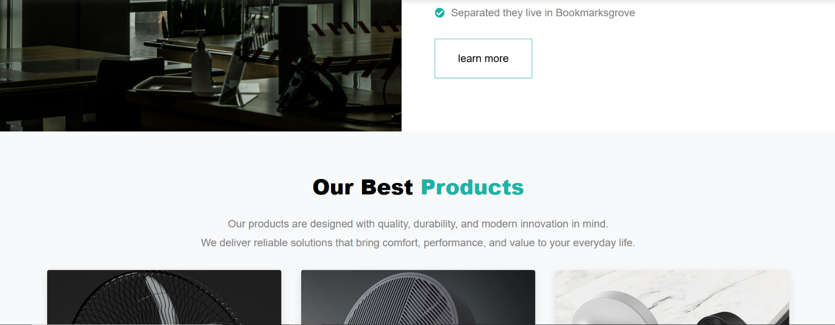
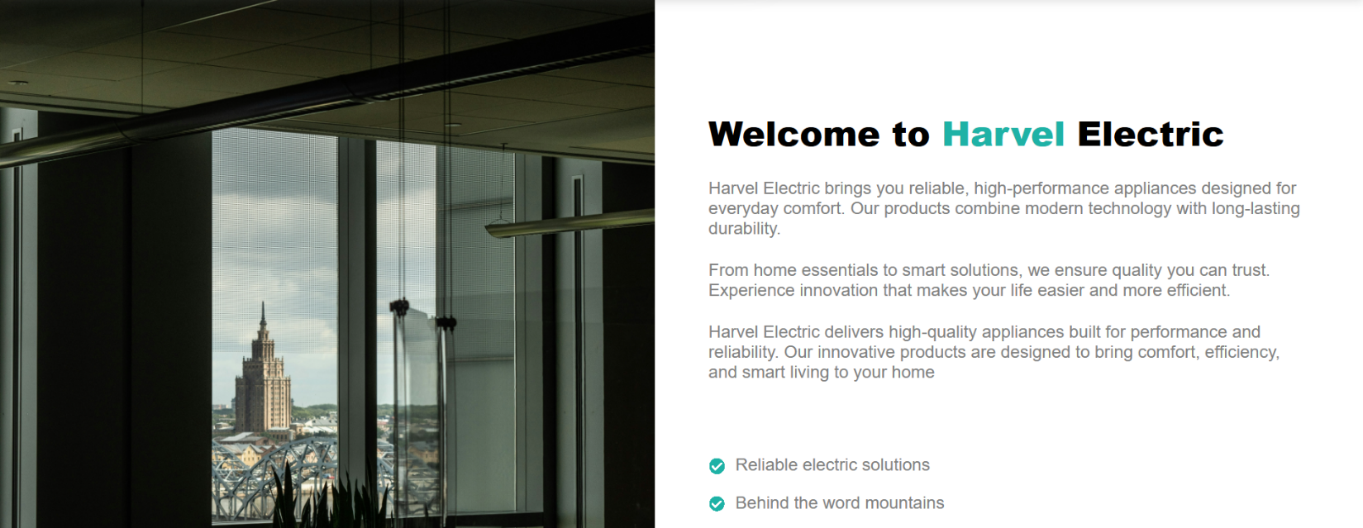
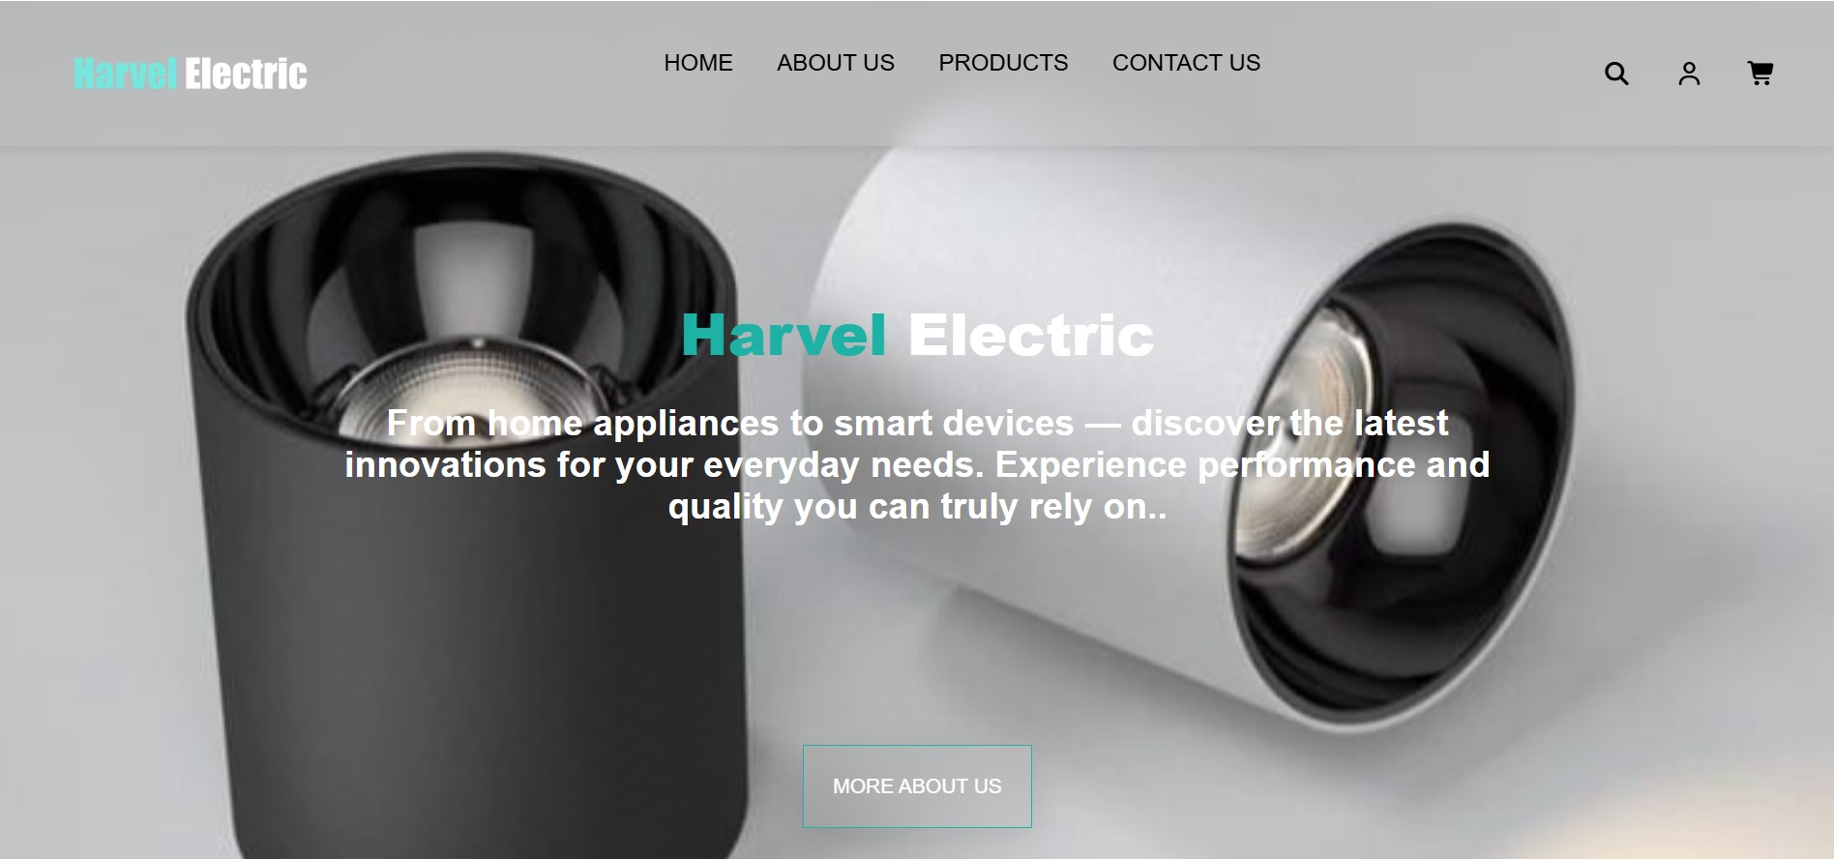

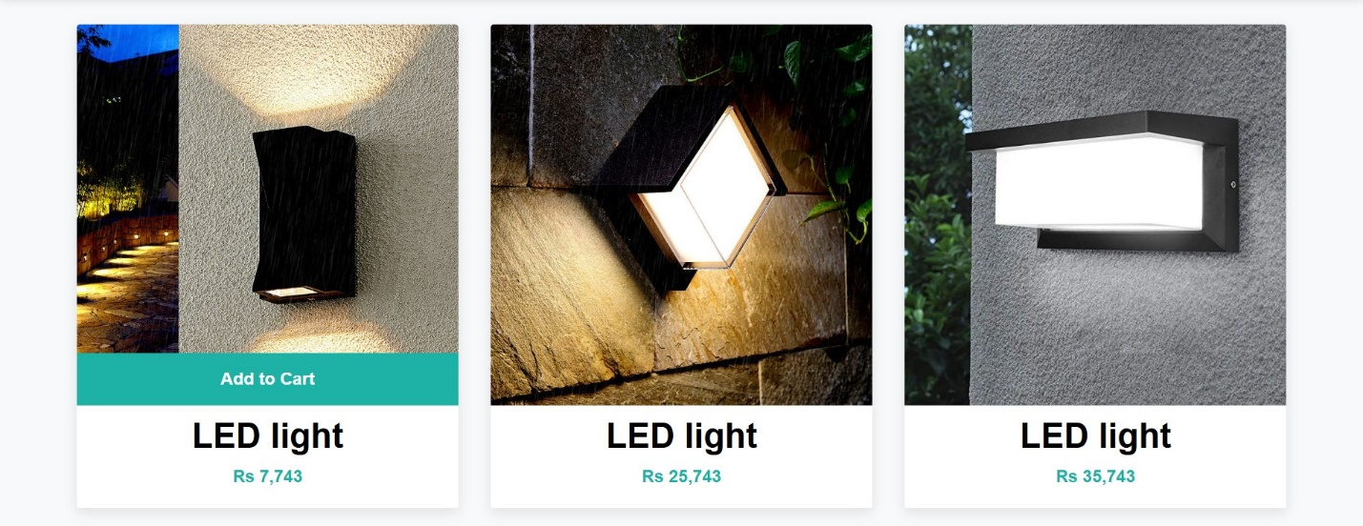
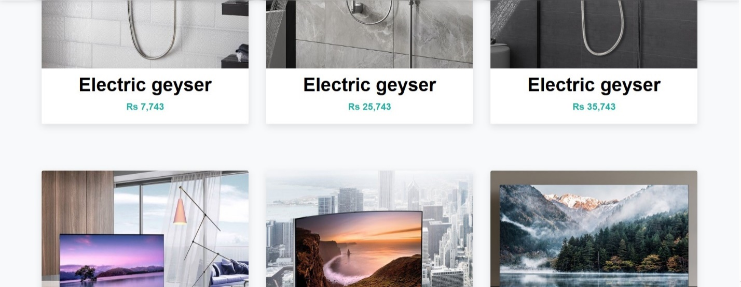
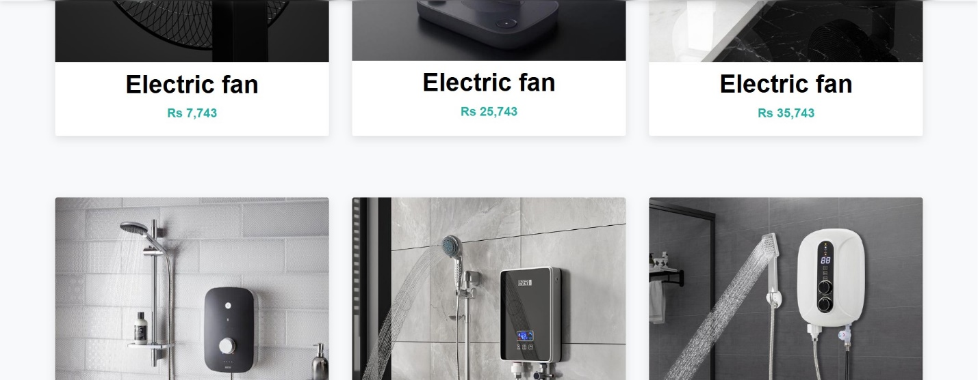
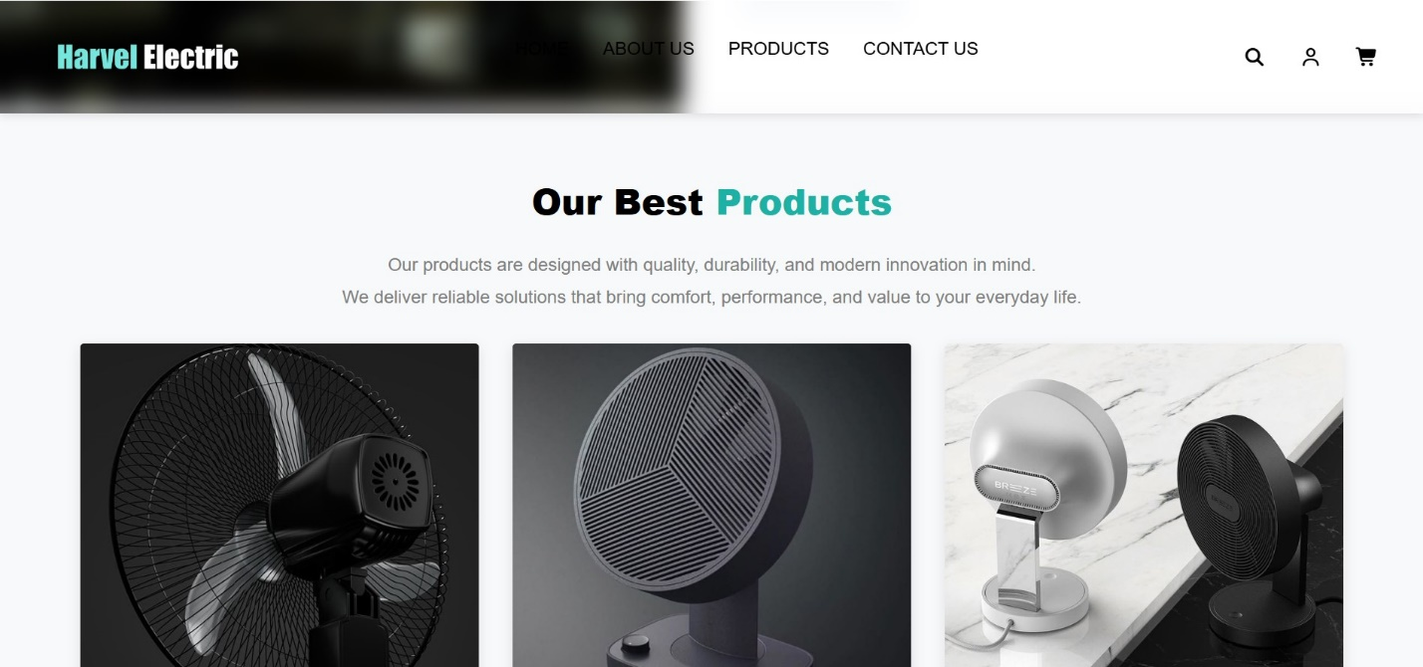

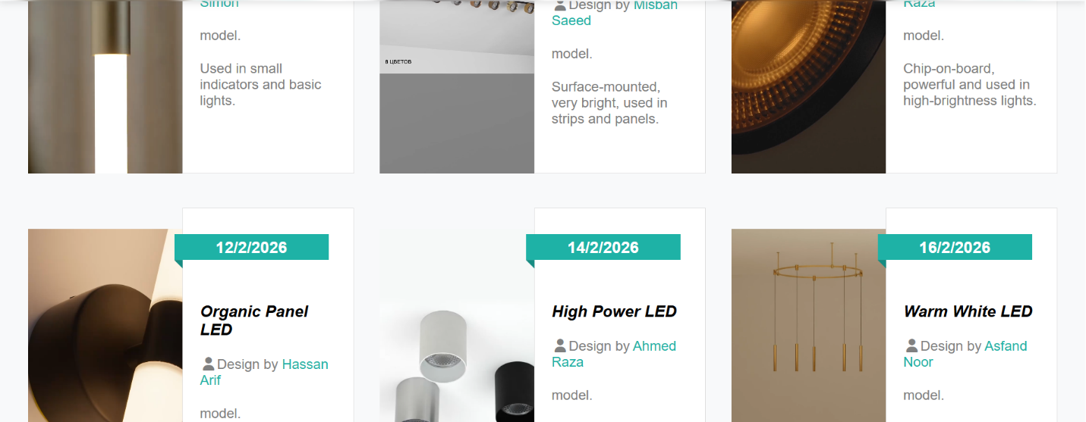
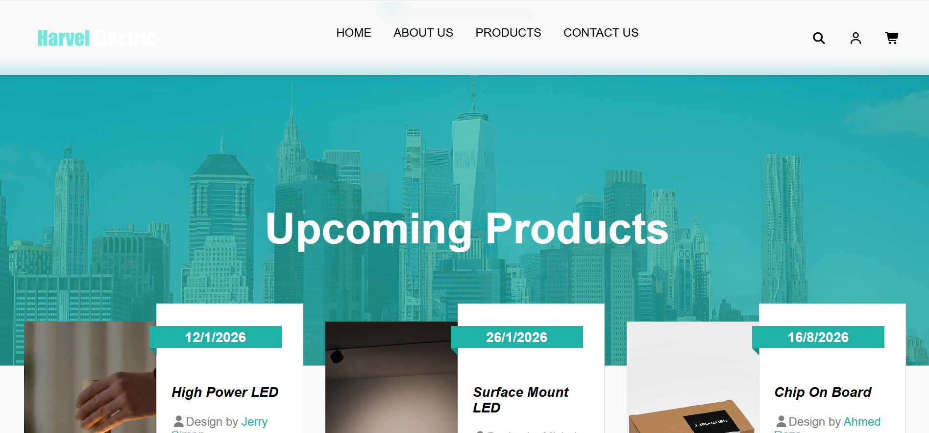
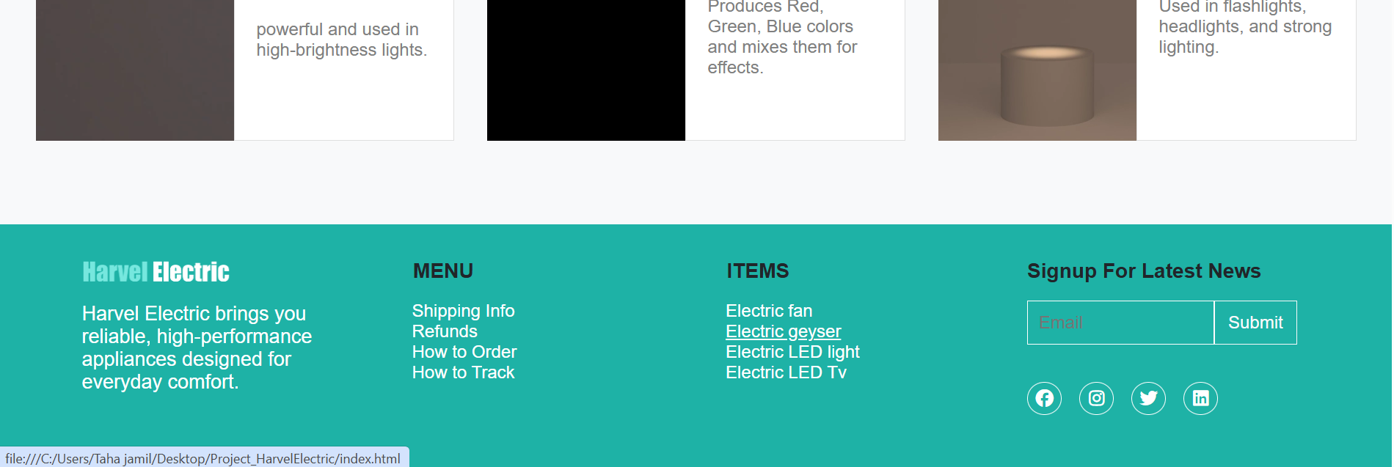

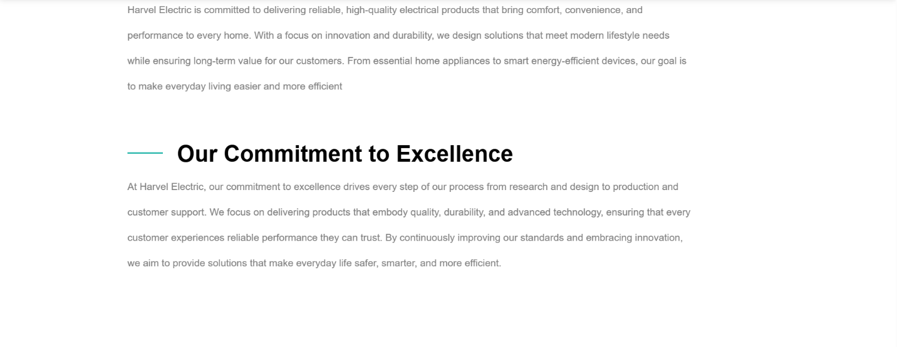
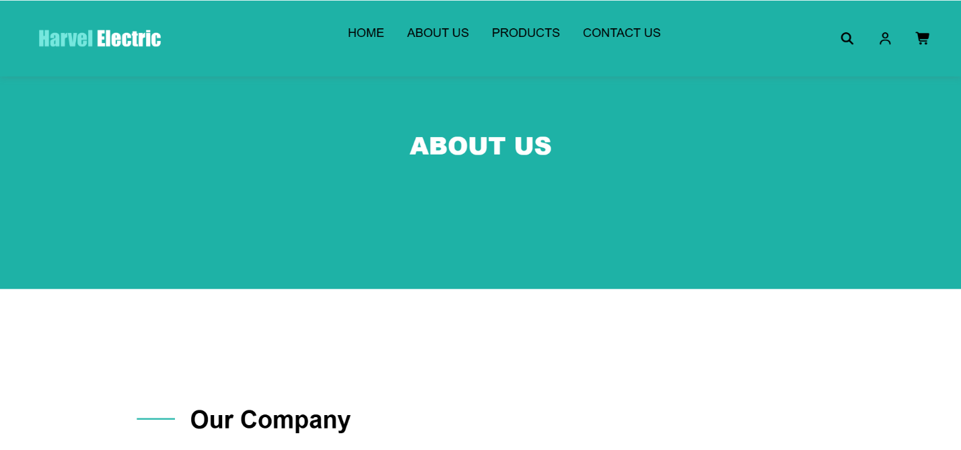
ABOUT

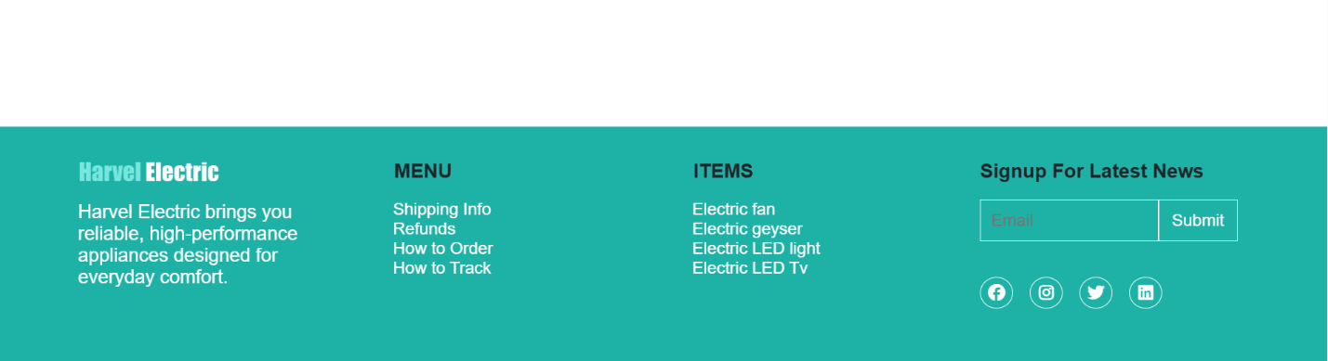
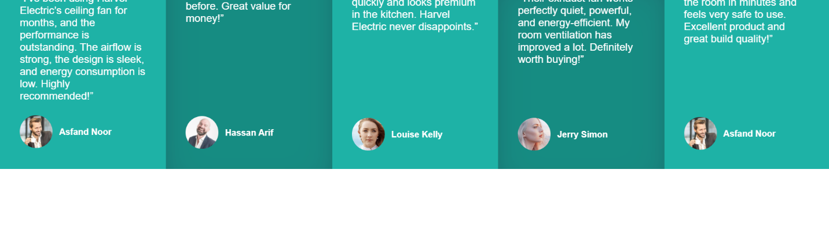
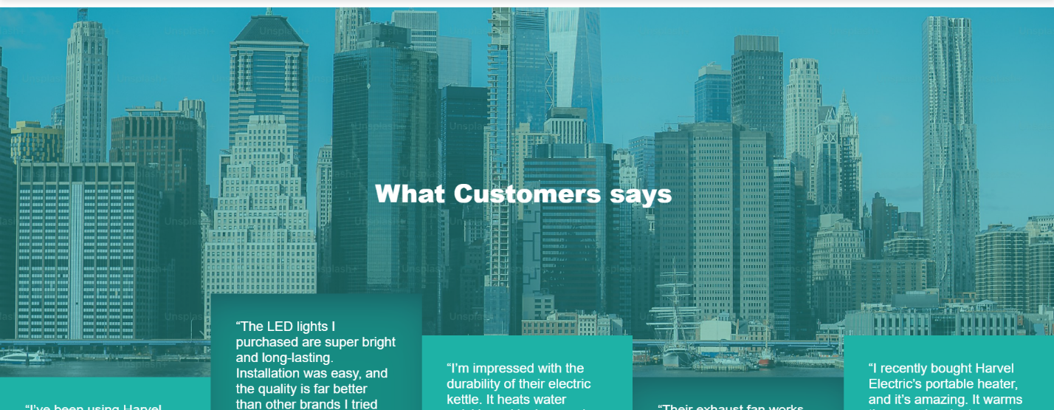
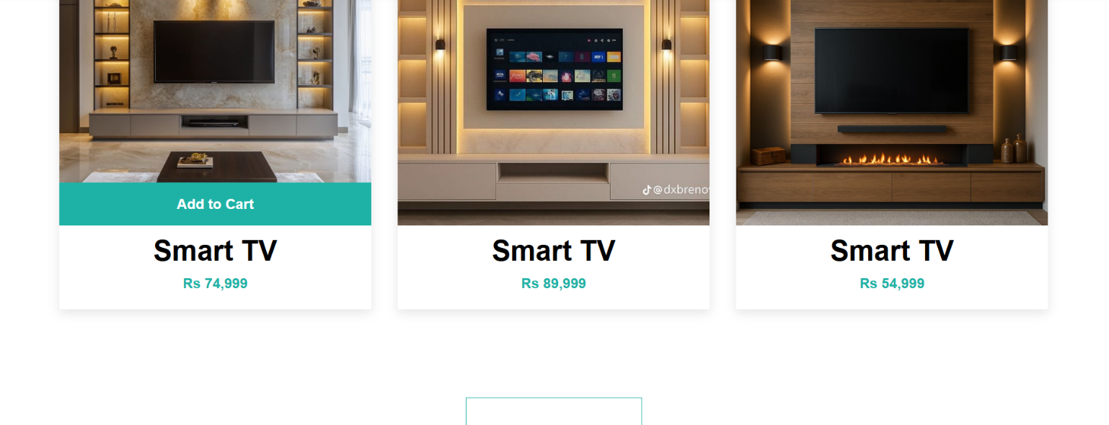
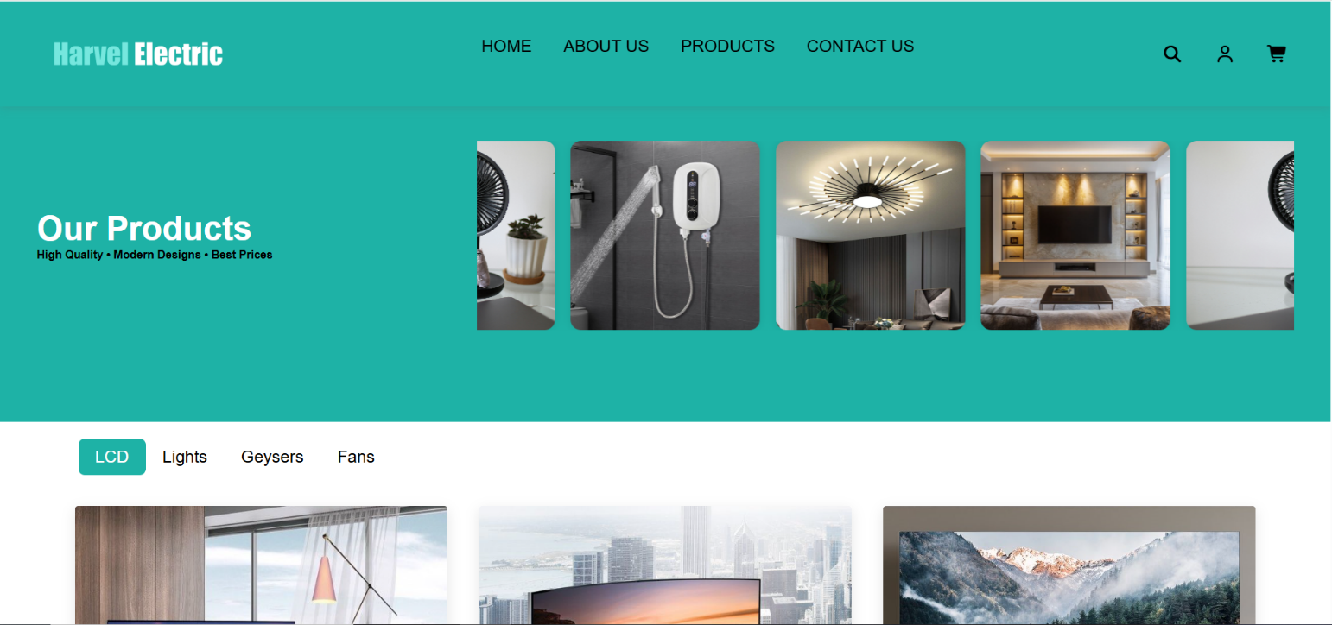
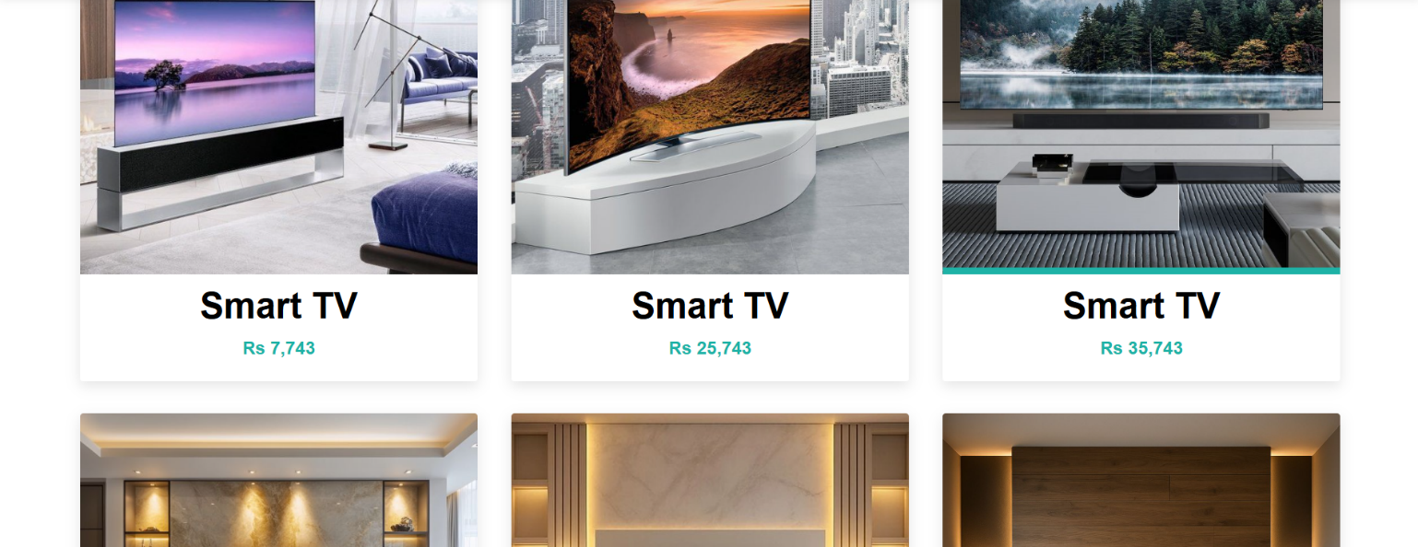
Products

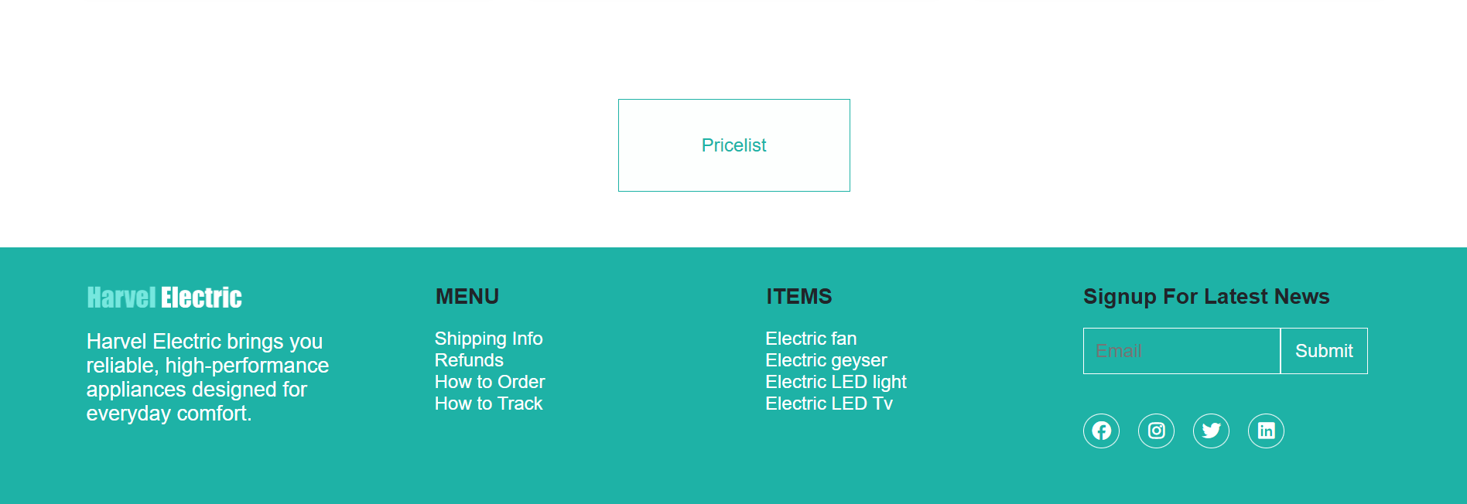

Contact
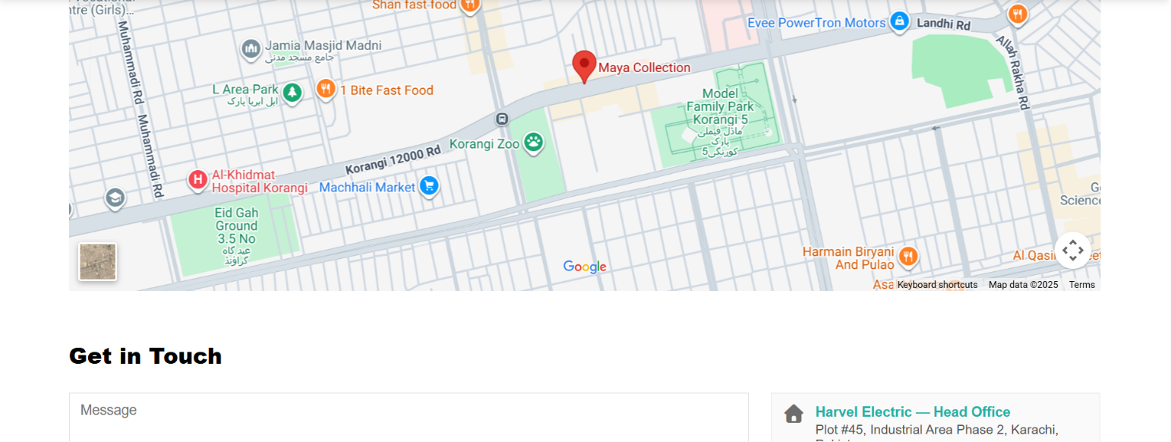
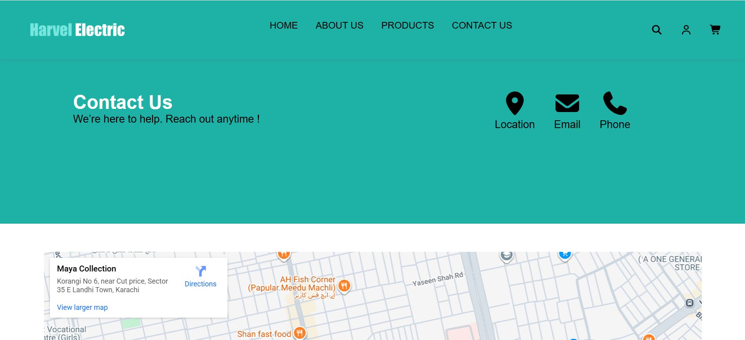

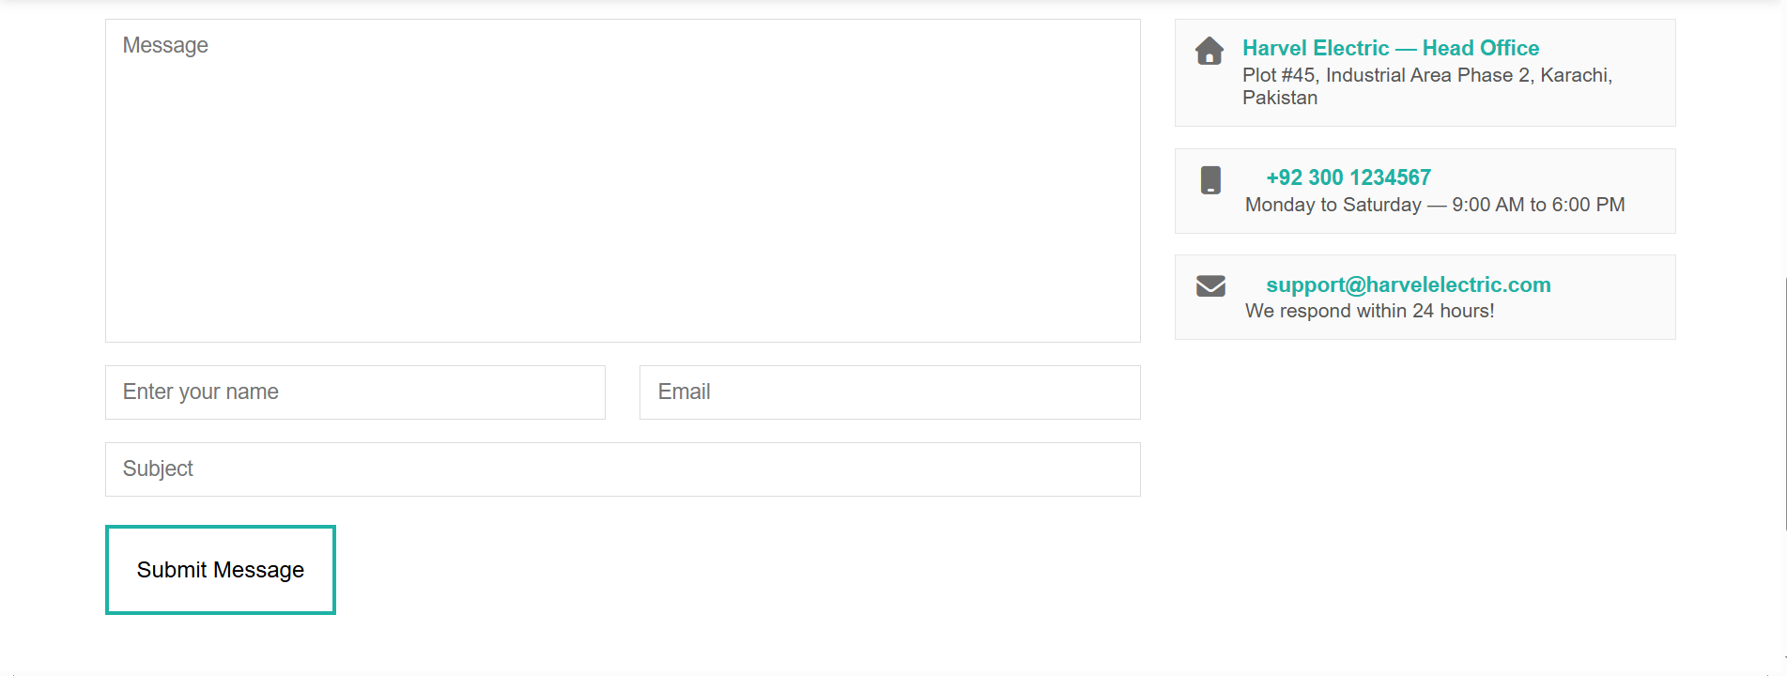

Index
<header>
<div class="navbar-logo">
<div class="humburger" onclick="showSidebar()">
<svg xmlns="http://www.w3.org/2000/svg" height="30px" viewBox="0 -960 960 960" width="30px"
fill="#000">
<path d="M120-240v-80h720v80H120Zm0-200v-80h720v80H120Zm0-200v-80h720v80H120Z" />
</svg>
</div>
<div id="logo"><img src="img/Artboard 1.png" alt="logo"></div>
</div>
<div class="navbar">
<ul>
<li><a href="">HOME</a></li>
<li><a href="About.html">ABOUT US</a></li>
<li><a href="product.html">PRODUCTS</a></li>
<li><a href="contact.html">CONTACT US</a></li>
</ul>
</div>
<div class="icon">
<i class="fa-solid fa-magnifying-glass"></i>
<i class="fa-regular fa-user"></i>
<i class="fa-solid fa-cart-shopping">
<!-- <div class="num">0</div> -->
</i>
</div>
</header>
<div class="sidebar">
<ul>
<li class="sidebar-list" id="sb-btn">
<i class="fa-solid fa-xmark" onclick="closeSidebar()"></i>
</li>
<li class="sidebar-list"><a href="">HOME</a></li>
<li class="sidebar-list"><a href="About.html">ABOUT US</a></li>
<li class="sidebar-list"><a href="product.html">PRODUCTS</a></li>
<li class="sidebar-list"><a href="contact.html">CONTACT US</a></li>
</ul>
</div>

<div class="Home_banner">
<div class="content">
<h1><b><span style="color: #1eb2a6;">Harvel</span> Electric</b></h1>
<h5>From home appliances to smart devices —
discover the latest innovations for your everyday needs.
Experience performance and quality you can truly rely on..</h5>
<button class="banner_btn">MORE ABOUT US</button>
</div>
</div>
<div class="main">
<div class="img_div">
<img class="first" src="img/company.jpg" alt="img">
<img class="second" src="img/company1.jpg" alt="img">
</div>
<div class="Harvel_content">
<h1><b>Welcome to <span style="color: #1eb2a6;">Harvel</span> Electric</b></h1>
<p>Harvel Electric brings you reliable, high-performance appliances designed for everyday comfort. Our
products combine modern technology with long-lasting durability.</p>
<p>
From home essentials to smart solutions, we ensure quality you can trust. Experience innovation that
makes your life easier and more efficient.
</p>
<p>
Harvel Electric delivers high-quality appliances built for performance and reliability.
Our innovative products are designed to bring comfort, efficiency, and smart living to your home
</p>
<div class="list">
<div class="list_img">
<div class="div1"></div>
<div class="div1"></div>
<div class="div1"></div>
</div>
<p>Reliable electric solutions</p>
<p> Behind the word mountains</p>
<p> Separated they live in Bookmarksgrove</p>
</div>
<button class="btn1"><a href="About.html">learn more</a></button>
</div>
</div>

<section>
<div class="height">

<!-- heading -->
<div class="heading">
<h1><b>Our Best<span style="color: #1eb2a6;"> Products</span></b></h1>
<p>Our products are designed with quality, durability, and modern innovation in mind.</p>
<p>We deliver reliable solutions that bring comfort, performance, and value to your everyday life.</p>
</div>
</section>
<section>

<div class="items_container">
<div class="item">
<div class="images">
<img src="img/fan1.jpg" alt="item-img">
<button class="batan">Add to Cart</button>
</div>
<h1><a href="fan1.html" class="items-list">Electric fan</a></h1>
<h4>Rs 7,743</h4>
</div>
<div class="item">
<div class="images">
<img src="img/fans4.jpg" alt="item-img">
<button class="batan">Add to Cart</button>
</div>

<h1><a href="fan2.html" class="items-list">Electric fan</a></h1>
<h4>Rs 25,743</h4>
</div>
<div class="item">
<div class="images">
<img src="img/fans5.jpg" alt="item-img">
<button class="batan">Add to Cart</button>
</div>

<h1><a href="fan3.html" class="items-list">Electric fan</a></h1>
<h4>Rs 35,743</h4>
</div>
<div class="item_block">
<div class="images">
<img src="img/block_img.jpg" alt="item-img">
<button class="batan">Add to Cart</button>
</div>

<h1><a href="fan4.html" class="items-list">Electric fan</a></h1>
<h4>Rs 35,743</h4>
</div>
</div>

<div class="items_container">
<div class="item">
<div class="images">
<img src="img/Electric geyser1.jpg" alt="item-img">
<button class="batan">Add to Cart</button>
</div>
<h1><a href="geyser1.html" class="items-list">Electric geyser</a></h1>
<h4>Rs 7,743</h4>
</div>
<div class="item">
<div class="images">
<img src="img/Electric geyser2.jpg" alt="item-img">
<button class="batan">Add to Cart</button>
</div>
<h1><a href="geyser2.html" class="items-list">Electric geyser</a></h1>
<h4>Rs 25,743</h4>
</div>
<div class="item">
<div class="images">
<img src="img/Electric geyser3.jpg" alt="item-img">
<button class="batan">Add to Cart</button>
</div>
<h1><a href="geyser3.html" class="items-list">Electric geyser</a></h1>
<h4>Rs 35,743</h4>
</div>
<div class="item_block">
<div class="images">
<img src="img/block_img1.jpg" alt="item-img">
<button class="batan">Add to Cart</button>
</div>
<h1><a href="geyser4.docx" class="items-list">Electric geyser</a></h1>
<h4>Rs 35,743</h4>
</div>
</div>

</section>
<section>
<div class="items_container">
<div class="item">
<div class="images">
<img src="img/LED TV4.jpg" alt="item-img">
<button class="batan">Add to Cart</button>
</div>
<h1><a href="LCD1.html" class="items-list">LED TV4</a></h1>
<h4>Rs 7,743</h4>
</div>
<div class="item">
<div class="images">
<img src="img/LED TV5.jpg" alt="item-img">
<button class="batan">Add to Cart</button>
</div>

<h1><a href="LCD2.html" class="items-list">LED TV4</a></h1>
<h4>Rs 25,743</h4>
</div>
<div class="item">
<div class="images">
<img src="img/LED TV6.jpg" alt="item-img">
<button class="batan">Add to Cart</button>
</div>
<h1><a href="LCD3.html" class="items-list">LED TV4</a></h1>
<h4>Rs 35,743</h4>
</div>
<div class="item_block">
<div class="images">
<img src="img/block_img2.jpg" alt="item-img">
<button class="batan">Add to Cart</button>
</div>
<h1><a href="LCD4.html" class="items-list">LED TV4</a></h1>
<h4>Rs 35,743</h4>
</div>
</div>
<div class="items_container">
<div class="item">
<div class="images">
<img src="img/light1.jpg" alt="item-img">
<button class="batan">Add to Cart</button>
</div>

<h1><a href="light1.html" class="items-list">LED light</a></h1>
<h4>Rs 7,743</h4>
</div>
<div class="item">
<div class="images">
<img src="img/light2.jpg" alt="item-img">
<button class="batan">Add to Cart</button>
</div>
<h1><a href="light2.html" class="items-list">LED light</a></h1>
<h4>Rs 25,743</h4>
</div>
<div class="item">
<div class="images">
<img src="img/light3.jpg" alt="item-img">
<button class="batan">Add to Cart</button>
</div>

<h1><a href="light2.html" class="items-list">LED light</a></h1>
<h4>Rs 35,743</h4>
</div>
<div class="item_block">
<div class="images">
<img src="img/block_img3.jpg" alt="item-img">
<button class="batan">Add to Cart</button>
</div>
<h1><a href="light4.html" class="items-list">LED light</a></h1>
<h4>Rs 35,743</h4>
</div>
</div>
<div class="Pricelist_div">
<button class="Pricelist_btn"><a href="Pricelist.xlsx">Pricelist</a></button>
</div>
</section>
<section>
<div class="banner2">
<img src="img/New york.jpg" alt="">
<h2>Upcoming Products</h2>
<div class="Amazing-content">

<div class="Amazing-content-row">
<div class="inrow">
<div class="vidio">
<video width="200px" src="img/video1.mp4" type="video/mp4" autoplay muted loop></video>
</div>
<div class="Amazing-colum">
<div class="date">
<h3>12/1/2026</h3>
<div class="clip"></div>
</div>
<h3><i>High Power LED</i></h3>
<p><i class="fa-solid fa-user"></i>Design by <span style="color: #1eb2a6;">Jerry
Simon</span></p>
<p>model.</p>
<p>Used in small indicators and basic lights.</p>
</div>
</div>
<div class="inrow">
<div class="vidio">
<video width="200px" src="img/video2.mp4" type="video/mp4" autoplay muted loop></video>
</div>
<div class="Amazing-colum">
<div class="date">
<h3>26/1/2026</h3>
<div class="clip"></div>
</div>
<h3><i>Surface Mount LED</i></h3>
<p><i class="fa-solid fa-user"></i>Design by <span style="color: #1eb2a6;">Misbah
Saeed</span></p>
<p>model.</p>
<p>Surface-mounted, very bright, used in strips and panels.</p>
</div>
</div>
<div class="inrow">
<div class="vidio">
<video width="200px" src="img/video3.mp4" type="video/mp4" autoplay muted loop></video>
</div>
<div class="Amazing-colum">
<div class="date">
<h3>16/8/2026</h3>
<div class="clip"></div>
</div>
<h3><i>Chip On Board</i></h3>
<p><i class="fa-solid fa-user"></i>Design by <span style="color: #1eb2a6;">Ahmed Raza</span>
</p>
<p>model.</p>
<p>Chip-on-board, powerful and used in high-brightness lights.</p>
</div>
</div>
<div class="inrow_block">
<div class="vidio">
<video width="200px" src="img/video7.mp4" type="video/mp4" autoplay muted loop></video>
</div>
<div class="Amazing-colum">
<div class="date">
<h3>16/8/2026</h3>
<div class="clip"></div>
</div>
<h3><i>Chip On Board</i></h3>
<p><i class="fa-solid fa-user"></i>Design by <span style="color: #1eb2a6;">Ahmed Raza</span>
</p>
<p>model.</p>
<p>Chip-on-board, powerful and used in high-brightness lights.</p>
</div>
</div>
</div>
</section>
<section>

<div class="Amazing-content-row1">
<div class="inrow">
<div class="vidio">
<video width="200px" src="img/video4.mp4" type="video/mp4" autoplay muted loop></video>
</div>
<div class="Amazing-colum">
<div class="date">
<h3>12/2/2026</h3>
<div class="clip"></div>
</div>
<h3><i>Organic Panel LED</i></h3>
<p><i class="fa-solid fa-user"></i>Design by <span style="color: #1eb2a6;">Hassan
Arif</span></p>
<p>model.</p>
<p> powerful and used in high-brightness lights.</p>
</div>
</div>
<div class="inrow">
<div class="vidio">
<video width="200px" src="img/video5.mp4" type="video/mp4" autoplay muted loop></video>
</div>
<div class="Amazing-colum">
<div class="date">
<h3>14/2/2026</h3>
<div class="clip"></div>
</div>
<h3><i>High Power LED</i></h3>
<p><i class="fa-solid fa-user"></i>Design by <span style="color: #1eb2a6;">Ahmed Raza</span>
</p>
<p>model.</p>
<p>Produces Red, Green, Blue colors and mixes them for effects.</p>
</div>
</div>
<div class="inrow">
<div class="vidio">
<video width="200px" src="img/video6.mp4" type="video/mp4" autoplay muted loop></video>
</div>
<div class="Amazing-colum">
<div class="date">
<h3>16/2/2026</h3>
<div class="clip"></div>
</div>
<h3><i>Warm White LED</i></h3>
<p><i class="fa-solid fa-user"></i>Design by <span style="color: #1eb2a6;">Asfand
Noor</span></p>
<p>model.</p>
<p>Used in flashlights, headlights, and strong lighting.</p>
</div>
</div>
<div class="inrow_block">
<div class="vidio">
<video width="200px" src="img/video8.mp4" type="video/mp4" autoplay muted loop></video>
</div>
<div class="Amazing-colum">
<div class="date">
<h3>16/8/2026</h3>
<div class="clip"></div>
</div>
<h3><i>Chip On Board</i></h3>
<p><i class="fa-solid fa-user"></i>Design by <span style="color: #1eb2a6;">Ahmed Raza</span>
</p>
<p>model.</p>
<p>Chip-on-board, powerful and used in high-brightness lights.</p>
</div>
</div>
</div>

</div>
</div>

</div>

</section>
</main>
<footer class="bg-teal p-3">
<div class="container">
<div class="row text-white">

<!-- Column 1 -->
<div class="col-lg-3 col-md-6 mb-4 mt-3">
<img id="footer-img" src="img/logo 1.png" alt="logo" class="img-fluid "
style="max-width:150px;">
<p class="footer-head">Harvel Electric brings you reliable, high-performance appliances designed
for everyday
comfort.</p>
</div>

<!-- Column 2 -->
<div class="col-lg-3 col-md-6 mb-4">
<h3 class="text-dark fw-bold p-3">MENU</h3>
<p><a href="" class="footer-link">Shipping Info</a></p>
<p><a href="" class="footer-link">Refunds</a></p>
<p><a href="" class="footer-link">How to Order</a></p>
<p><a href="" class="footer-link">How to Track</a></p>
</div>

<!-- Column 3 -->
<div class="col-lg-3 col-md-6 mb-4">
<h3 class="text-dark fw-bold p-3 ">ITEMS</h3>
<p><a href="" class="footer-link ">Electric fan</a></p>
<p><a href="" class="footer-link ">Electric geyser</a></p>
<p><a href="" class="footer-link ">Electric LED light</a></p>
<p><a href="" class="footer-link ">Electric LED Tv</a></p>
</div>

<!-- Column 4 -->
<div class="col-lg-3 col-md-6 p-3 ppol">
<h3 class="text-dark fw-bold mb-3">Signup For Latest News</h3>

<div class="d-flex ">
<input class="footer_input" type="email" class="form-control me-2 rounded-0" placeholder="Email">
<button class="btn btn-outline-light rounded-0 mt-0">Submit</button>
</div>

<div class="d-flex gap-3 mt-1">
<a class="social-icon" href="#"><i class="fa-brands fa-facebook"></i></a>
<a class="social-icon" href="#"><i class="fa-brands fa-instagram"></i></a>
<a class="social-icon" href="#"><i class="fa-brands fa-twitter"></i></a>
<a class="social-icon" href="#"><i class="fa-brands fa-linkedin"></i></a>
</div>
</div>

</div>
</div>
</footer>

ABOUT
<!DOCTYPE html>
<html lang="en">
<head>
<meta charset="UTF-8">
<meta name="viewport" content="width=device-width, initial-scale=1.0">
<title>Document</title>
<link rel="stylesheet" href="style.css">
<link rel="stylesheet" href="media_query.css">
<link rel="stylesheet" href="css/bootstrap.css">
<link rel="stylesheet" href="https://cdnjs.cloudflare.com/ajax/libs/font-awesome/7.0.1/css/all.min.css"
integrity="sha512-2SwdPD6INVrV/lHTZbO2nodKhrnDdJK9/kg2XD1r9uGqPo1cUbujc+IYdlYdEErWNu69gVcYgdxlmVmzTWnetw=="
crossorigin="anonymous" referrerpolicy="no-referrer" />
</head>
<body>

<header>
<div class="navbar-logo">
<div class="humburger" onclick="showSidebar()">
<svg xmlns="http://www.w3.org/2000/svg" height="30px" viewBox="0 -960 960 960" width="30px"
fill="#000">
<path d="M120-240v-80h720v80H120Zm0-200v-80h720v80H120Zm0-200v-80h720v80H120Z" />
</svg>
</div>
<div id="logo"><img src="img/Artboard 1.png" alt="logo"></div>
</div>
<div class="navbar">
<ul>
<li><a href="index.html">HOME</a></li>
<li><a href="">ABOUT US</a></li>
<li><a href="product.html">PRODUCTS</a></li>
<li><a href="contact.html">CONTACT US</a></li>
</ul>
</div>
<div class="icon">
<i class="fa-solid fa-magnifying-glass"></i>
<i class="fa-regular fa-user"></i>
<i class="fa-solid fa-cart-shopping">
<!-- <div class="num">0</div> -->
</i>
</div>
</header>
<div class="sidebar">
<ul>
<li class="sidebar-list" id="sb-btn">
<i class="fa-solid fa-xmark" onclick="closeSidebar()"></i>
</li>
<li class="sidebar-list"><a href="index.html">HOME</a></li>
<li class="sidebar-list"><a href="About.html">ABOUT US</a></li>
<li class="sidebar-list"><a href="product.html">PRODUCTS</a></li>
<li class="sidebar-list"><a href="contact.html">CONTACT US</a></li>
</ul>
</div>

<section>
<div class="About_banner">
<h1><b>ABOUT US</b></h1>
</div>
</section>
<section>
<div class="About_main">
<div class="About_content">
<div class="line"></div>
<h1>Our Company</h1>

<p>
Harvel Electric is committed to delivering reliable, high-quality electrical products that bring comfort, convenience, and</p><p>performance to every home. With a focus on innovation and durability, we design solutions that meet modern lifestyle needs</p><p> while ensuring long-term value for our customers. From essential home appliances to smart energy-efficient devices, our goal is</p><p>to make everyday living easier and more efficient </p>

</div>
<div class="About_content">
<div class="line"></div>
<h1>Our Commitment to Excellence</h1>

<p>

At Harvel Electric, our commitment to excellence drives every step of our process from research and design to production and</p><p> customer support. We focus on delivering products that embody quality, durability, and advanced technology, ensuring that every</p><p> customer experiences reliable performance they can trust. By continuously improving our standards and embracing innovation,</p><p> we aim to provide solutions that make everyday life safer, smarter, and more efficient.</p></p>

</div>
</div>
</section>

<section>
<div class="About_img">
<h1><b>What Customers says</b></h1>
<div class="costomer">
<div class="costomer_col1">
<p>
“I’ve been using Harvel Electric’s ceiling fan for months, and the performance is outstanding. The airflow is strong, the design is sleek, and energy consumption is low. Highly recommended!”</p>
<div class="costomer_contant1">
<div class="costomer_img">
<img src="img/person_1.jpg" alt="">
</div>
<h5>Asfand Noor</h5>
</div>
</div>
<div class="costomer_col2">
<p>
“The LED lights I purchased are super bright and long-lasting. Installation was easy, and the quality is far better than other brands I tried before. Great value for money!”</p>
<div class="costomer_contant2">
<div class="costomer_img">
<img src="img/person_2.jpg" alt="">
</div>
<h5>Hassan Arif</h5>
</div>
</div>
<div class="costomer_col3">
<p>

“I’m impressed with the durability of their electric kettle. It heats water quickly and looks premium in the kitchen. Harvel Electric never disappoints.”
</p>
<div class="costomer_contant3">
<div class="costomer_img">
<img src="img/parson_3.png" alt="">
</div>
<h5>Louise Kelly</h5>
</div>
</div>
<div class="costomer_col4">
<p>

“Their exhaust fan works perfectly quiet, powerful, and energy-efficient. My room ventilation has improved a lot. Definitely worth buying!”
</p>
<div class="costomer_contant4">
<div class="costomer_img">
<img src="img/parson_4.png" alt="">
</div>
<h5>Jerry Simon</h5>
</div>
</div>
<div class="costomer_col5">
<p>

“I recently bought Harvel Electric’s portable heater, and it’s amazing. It warms the room in minutes and feels very safe to use. Excellent product and great build quality!”
</p>
<div class="costomer_contant5">
<div class="costomer_img">
<img src="img/person_1.jpg" alt="">
</div>
<h5>Asfand Noor</h5>
</div>
</div>
</div>
</div>
</section>

<footer class="bg-teal p-3 footer-top">
<div class="container ">
<div class="row text-white ">

<!-- Column 1 -->
<div class="col-lg-3 col-md-6 mb-4 mt-3">
<img id="footer-img" src="img/logo 1.png" alt="logo" class="img-fluid "
style="max-width:150px;">
<p class="footer-head">Harvel Electric brings you reliable, high-performance appliances designed
for everyday
comfort.</p>
</div>

<!-- Column 2 -->
<div class="col-lg-3 col-md-6 mb-4">
<h3 class="text-dark fw-bold p-3">MENU</h3>
<p><a href="" class="footer-link">Shipping Info</a></p>
<p><a href="" class="footer-link">Refunds</a></p>
<p><a href="" class="footer-link">How to Order</a></p>
<p><a href="" class="footer-link">How to Track</a></p>
</div>

<!-- Column 3 -->
<div class="col-lg-3 col-md-6 mb-4">
<h3 class="text-dark fw-bold p-3 ">ITEMS</h3>
<p><a href="" class="footer-link ">Electric fan</a></p>
<p><a href="" class="footer-link ">Electric geyser</a></p>
<p><a href="" class="footer-link ">Electric LED light</a></p>
<p><a href="" class="footer-link ">Electric LED Tv</a></p>
</div>

<!-- Column 4 -->
<div class="col-lg-3 col-md-6 p-3 ppol">
<h3 class="text-dark fw-bold mb-3">Signup For Latest News</h3>

<div class="d-flex ">
<input class="footer_input" type="email" class="form-control me-2 rounded-0" placeholder="Email">
<button class="btn btn-outline-light rounded-0 mt-0">Submit</button>
</div>

<div class="d-flex gap-3 mt-1">
<a class="social-icon" href="#"><i class="fa-brands fa-facebook"></i></a>
<a class="social-icon" href="#"><i class="fa-brands fa-instagram"></i></a>
<a class="social-icon" href="#"><i class="fa-brands fa-twitter"></i></a>
<a class="social-icon" href="#"><i class="fa-brands fa-linkedin"></i></a>
</div>
</div>

</div>
</div>
</footer>

</body>
</html>

PORDUCT
<!DOCTYPE html>
<html lang="en">

<head>
<meta charset="UTF-8">
<meta name="viewport" content="width=device-width, initial-scale=1.0">
<title>Products</title>
<link rel="stylesheet" href="style.css">
<link rel="stylesheet" href="media_query.css">
<link rel="stylesheet" href="css/bootstrap.css">
<link rel="stylesheet" href="css/bootstrap-utilities.rtl.min.css">
<link rel="stylesheet" href="https://cdnjs.cloudflare.com/ajax/libs/font-awesome/7.0.1/css/all.min.css"
integrity="sha512-2SwdPD6INVrV/lHTZbO2nodKhrnDdJK9/kg2XD1r9uGqPo1cUbujc+IYdlYdEErWNu69gVcYgdxlmVmzTWnetw=="
crossorigin="anonymous" referrerpolicy="no-referrer" />
</head>

<body >
<!-- navbar -->
<header>
<div class="navbar-logo">
<div class="humburger" onclick="showSidebar()">
<svg xmlns="http://www.w3.org/2000/svg" height="30px" viewBox="0 -960 960 960" width="30px" fill="#000">
<path d="M120-240v-80h720v80H120Zm0-200v-80h720v80H120Zm0-200v-80h720v80H120Z" />
</svg>
</div>
<div id="logo"><img src="img/Artboard 1.png" alt="logo"></div>
</div>
<div class="navbar">
<ul>
<li><a href="index.html">HOME</a></li>
<li><a href="About.html">ABOUT US</a></li>
<li><a href="product.html">PRODUCTS</a></li>
<li><a href="contact.html">CONTACT US</a></li>
</ul>
</div>
<div class="icon">
<i class="fa-solid fa-magnifying-glass"></i>
<i class="fa-regular fa-user"></i>
<i class="fa-solid fa-cart-shopping">
<!-- <div class="num">0</div> -->
</i>
</div>
</header>
<div class="sidebar">
<ul>
<li class="sidebar-list" id="sb-btn">
<i class="fa-solid fa-xmark" onclick="closeSidebar()"></i>
</li>
<li class="sidebar-list"><a href="index.html">HOME</a></li>
<li class="sidebar-list"><a href="">ABOUT US</a></li>
<li class="sidebar-list"><a href="product.html">PRODUCTS</a></li>
<li class="sidebar-list"><a href="contact.html">CONTACT US</a></li>
</ul>
</div>

<main>
<!-- slider-area start -->
<div class="banner-products">

<div class="left-text">
<h1 class="text-white">Our Products</h1>
<h6 class="fw-bold">High Quality • Modern Designs • Best Prices</h6>
</div>
<div class="right-slider">
<div class="slides">
<img src="img/light5.jpg" alt="img not found">
<img src="img/LED TV1.jpg" alt="img not found">
<img src="img/fan8.jpg" alt="img not found">
<img src="img/Electric geyser3.jpg" alt="img not found">

<img src="img/light5.jpg" alt="img not found">
<img src="img/LED TV1.jpg" alt="img not found">
<img src="img/fan8.jpg" alt="img not found">
<img src="img/Electric geyser3.jpg" alt="img not found">
</div>

</div>
</div>
<!-- slider-area end -->
<!-- <section>
<div class="headings">
<h3><a href="LCD.html" class="items-list">LCD</a></h3>
<h3><a href="light.html" class="items-list">Lights</a></h3>
<h3><a href="geyser.html" class="items-list">Geysers</a></h3>
<h3><a href="fans.html" class="items-list">Fans</a></h3>
</div>
<div class="items_container1">
<div class="item">
<div class="images">
<img src="img/LED TV4.jpg" alt="item-img">
<button class="batan">Add to Cart</button>
</div>
<h1><a href="LCD4.html" class="items-list">Smart TV</a></h1>
<h4>Rs 7,743</h4>
</div>
<div class="item">
<div class="images">
<img src="img/LED TV5.jpg" alt="item-img">
<button class="batan">Add to Cart</button>
</div>
<h1><a href="LCD5.html" class="items-list">Smart TV</a></h1>
<h4>Rs 25,743</h4>
</div>
<div class="item">
<div class="images">
<img src="img/LED TV6.jpg" alt="item-img">
<button class="batan">Add to Cart</button>
</div>
<h1><a href="LCD6.html" class="items-list">Smart TV</a></h1>
<h4>Rs 35,743</h4>
</div>
<div class="item block-item">
<div class="images">
<img src="img/LED TV3.jpg" alt="item-img">
<button class="batan">Add to Cart</button>
</div>
<h1><a href="LCD3.html" class="items-list">Smart TV</a></h1>
<h4>Rs 99,999</h4>
</div>
</div>
<h3 class="single-head"><a href="light.html" class="items-list">Lights</a></h3>
<div class="items_container1">
<div class="item">
<div class="images">
<img src="img/light1.jpg" alt="item-img">
<button class="batan">Add to Cart</button>
</div>
<h1><a href="light8.html" class="items-list">Decorative Light</a></h1>
<h4>Rs 4,499</h4>
</div>
<div class="item">
<div class="images">
<img src="img/light2.jpg" alt="item-img">
<button class="batan">Add to Cart</button>
</div>
<h1><a href="light2.html" class="items-list">Decorative Light</a></h1>
<h4>Rs 6,499</h4>
</div>
<div class="item">
<div class="images">
<img src="img/light3.jpg" alt="item-img">
<button class="batan">Add to Cart</button>
</div>
<h1><a href="light7.html" class="items-list">Decorative Light</a></h1>
<h4>Rs 4,999</h4>
</div>
<div class="item block-item">
<div class="images">
<img src="img/light4.jpg" alt="item-img">
<button class="batan">Add to Cart</button>
</div>
<h1><a href="light6.html" class="items-list">Decorative Light</a></h1>
<h4>Rs 3,499</h4>
</div>
</div>
<h3 class="single-head"><a href="" class="items-list">Geysers</a></h3>
<div class="items_container1">
<div class="item">
<div class="images">
<img src="img/Electric geyser1.jpg" alt="item-img">
<button class="batan">Add to Cart</button>
</div>
<h1><a href="geyser3.html" class="items-list">Electric geyser</a></h1>
<h4>Rs 11,499</h4>
</div>
<div class="item">
<div class="images">
<img src="img/Electric geyser2.jpg" alt="item-img">
<button class="batan">Add to Cart</button>
</div>
<h1><a href="geyser2.html" class="items-list">Electric geyser</a></h1>
<h4>Rs 14,999</h4>
</div>
<div class="item">
<div class="images">
<img src="img/Electric geyser3.jpg" alt="item-img">
<button class="batan">Add to Cart</button>
</div>
<h1><a href="geyser4.html" class="items-list">Electric geyser</a></h1>
<h4>Rs 13,499</h4>
</div>
<div class="item block-item">
<div class="images">
<img src="img/Electric geyser5.jpg" alt="item-img">
<button class="batan">Add to Cart</button>
</div>
<h1><a href="geyser5.html" class="items-list">Electric geyser</a></h1>
<h4>Rs 15,999</h4>
</div>,
</div>
<h3 class="single-head"><a href="" class="items-list">Fans</a></h3>
<div class="items_container1">
<div class="item">
<div class="images">
<img src="img/fans3.jpg" alt="item-img">
<button class="batan">Add to Cart</button>
</div>
<h1><a href="fan4.html" class="items-list">Electric Fans</a></h1>
<h4>Rs 2,150</h4>
</div>
<div class="item">
<div class="images">
<img src="img/fans4.jpg" alt="item-img">
<button class="batan">Add to Cart</button>
</div>
<h1><a href="fan3.html" class="items-list">Electric Fans</a></h1>
<h4>Rs 3,750</h4>
</div>
<div class="item">
<div class="images">
<img src="img/fan1.jpg" alt="item-img">
<button class="batan">Add to Cart</button>
</div>
<h1><a href="fan8.html" class="items-list">Electric Fans</a></h1>
<h4>Rs 1,450</h4>
</div>
<div class="item block-item">
<img src="img/fan10.jpg" alt="item-img">
<h1><a href="fan5.html" class="items-list">Electric Fans</a></h1>
<h4>Rs 9,500</h4>
</div>
</div>
</section> -->
<div class="container my-3">

<ul class="nav nav-pills mb-3" id="pills-tab" role="tablist">
<li class="nav-item" role="presentation">
<button class="nav-link active" id="pills-lcd-tab" data-bs-toggle="pill" data-bs-target="#pills-lcd"
type="button" role="tab">LCD</button>
</li>

<li class="nav-item" role="presentation">
<button class="nav-link " id="pills-lights-tab" data-bs-toggle="pill" data-bs-target="#pills-lights"
type="button" role="tab">Lights</button>
</li>

<li class="nav-item" role="presentation">
<button class="nav-link" id="pills-geysers-tab" data-bs-toggle="pill" data-bs-target="#pills-geysers"
type="button" role="tab">Geysers</button>
</li>

<li class="nav-item" role="presentation">
<button class="nav-link" id="pills-fans-tab" data-bs-toggle="pill" data-bs-target="#pills-fans"
type="button" role="tab">Fans</button>
</li>
</ul>
</div>

<div class="tab-content" id="pills-tabContent">

<div class="tab-pane fade show active" id="pills-lcd" role="tabpanel" tabindex="0">
<div class="items_container1">
<div class="item">
<div class="images">
<img src="img/LED TV4.jpg" alt="item-img">
<button class="batan">Add to Cart</button>
</div>
<h1><a href="LCD4.html" class="items-list">Smart TV</a></h1>
<h4>Rs 7,743</h4>
</div>
<!-- <div class="item">
<div class="images">
<img src="img/LED TV4.jpg" alt="item-img">
<button class="batan">Add to Cart</button>
</div>
<h1><a href="LCD4.html" class="items-list">Smart TV</a></h1>
<h4>Rs 7,743</h4>
</div> -->

<div class="item">
<div class="images">
<img src="img/LED TV5.jpg" alt="item-img">
<button class="batan">Add to Cart</button>
</div>
<h1><a href="LCD5.html" class="items-list">Smart TV</a></h1>
<h4>Rs 25,743</h4>
</div>

<div class="item">
<div class="images">
<img src="img/LED TV6.jpg" alt="item-img">
<button class="batan">Add to Cart</button>
</div>
<h1><a href="LCD6.html" class="items-list">Smart TV</a></h1>
<h4>Rs 35,743</h4>
</div>

<div class="item block-item">
<div class="images">
<img src="img/LED TV3.jpg" alt="item-img">
<button class="batan">Add to Cart</button>
</div>
<h1><a href="LCD3.html" class="items-list">Smart TV</a></h1>
<h4>Rs 99,999</h4>
</div>
</div>
<div class="items_container1">
<div class="item">
<div class="images">
<img src="img/LED TV1.jpg" alt="item-img">
<button class="batan">Add to Cart</button>
</div>
<h1><a href="LCD1.html" class="items-list">Smart TV</a></h1>
<h4>Rs 74,999</h4>
</div>
<div class="item">
<div class="images">
<img src="img/LED TV2.jpg" alt="item-img">
<button class="batan">Add to Cart</button>
</div>
<h1><a href="LCD2.html" class="items-list">Smart TV</a></h1>
<h4>Rs 89,999</h4>
</div>
<div class="item">
<div class="images">
<img src="img/LED TV9.jpg" alt="item-img">
<button class="batan">Add to Cart</button>
</div>
<h1><a href="LCD7.html" class="items-list">Smart TV</a></h1>
<h4>Rs 54,999</h4>
</div>
<div class="item block-item">
<div class="images">
<img src="img/LED TV8.jpg" alt="item-img">
<button class="batan">Add to Cart</button>
</div>
<h1><a href="LCD8.html" class="items-list">Smart TV</a></h1>
<h4>Rs 62,999</h4>
</div>
</div>
</div>

<div class="tab-pane fade" id="pills-lights" role="tabpanel" tabindex="0">
<div class="items_container1">
<div class="item">
<div class="images">
<img src="img/light1.jpg" alt="item-img">
<button class="batan">Add to Cart</button>
</div>
<h1><a href="light8.html" class="items-list">Decorative Light</a></h1>
<h4>Rs 4,499</h4>
</div>

<div class="item">
<div class="images">
<img src="img/light2.jpg" alt="item-img">
<button class="batan">Add to Cart</button>
</div>
<h1><a href="light2.html" class="items-list">Decorative Light</a></h1>
<h4>Rs 6,499</h4>
</div>

<div class="item">
<div class="images">
<img src="img/light3.jpg" alt="item-img">
<button class="batan">Add to Cart</button>
</div>
<h1><a href="light7.html" class="items-list">Decorative Light</a></h1>
<h4>Rs 4,999</h4>
</div>

<div class="item block-item">
<div class="images">
<img src="img/light4.jpg" alt="item-img">
<button class="batan">Add to Cart</button>
</div>
<h1><a href="light6.html" class="items-list">Decorative Light</a></h1>
<h4>Rs 3,499</h4>
</div>
</div>
<div class="items_container1">
<div class="item">
<div class="images">
<img src="img/light5.jpg" alt="item-img">
<button class="batan">Add to Cart</button>
</div>
<h1><a href="light5.html" class="items-list">Decorative Light</a></h1>
<h4>Rs 15,999</h4>
</div>
<div class="item">
<div class="images">
<img src="img/light6.jpg" alt="item-img">
<button class="batan">Add to Cart</button>
</div>
<h1><a href="light4.html" class="items-list">Decorative Light</a></h1>
<h4>Rs 11,499</h4>
</div>
<div class="item">
<div class="images">
<img src="img/light8.jpg" alt="item-img">
<button class="batan">Add to Cart</button>
</div>
<h1><a href="light2.html" class="items-list">Decorative Light</a></h1>
<h4>Rs 6,499</h4>
</div>
<div class="item block-item">
<div class="images">
<img src="img/light7.jpg" alt="item-img">
<button class="batan">Add to Cart</button>
</div>
<h1><a href="light3.html" class="items-list">Decorative Light</a></h1>
<h4>Rs 8,999</h4>
</div>
</div>

</div>

<div class="tab-pane fade" id="pills-geysers" role="tabpanel" tabindex="0">
<div class="items_container1">
<div class="item">
<div class="images">
<img src="img/Electric geyser1.jpg" alt="item-img">
<button class="batan">Add to Cart</button>
</div>
<h1><a href="geyser3.html" class="items-list">Electric geyser</a></h1>
<h4>Rs 11,499</h4>
</div>

<div class="item">
<div class="images">
<img src="img/Electric geyser2.jpg" alt="item-img">
<button class="batan">Add to Cart</button>
</div>
<h1><a href="geyser2.html" class="items-list">Electric geyser</a></h1>
<h4>Rs 14,999</h4>
</div>

<div class="item">
<div class="images">
<img src="img/Electric geyser3.jpg" alt="item-img">
<button class="batan">Add to Cart</button>
</div>
<h1><a href="geyser4.html" class="items-list">Electric geyser</a></h1>
<h4>Rs 13,499</h4>
</div>

<div class="item block-item">
<div class="images">
<img src="img/Electric geyser5.jpg" alt="item-img">
<button class="batan">Add to Cart</button>
</div>
<h1><a href="geyser5.html" class="items-list">Electric geyser</a></h1>
<h4>Rs 15,999</h4>
</div>
</div>
<div class="items_container1">
<div class="item">
<div class="images">
<img src="img/Electric geyser5.jpg" alt="item-img">
<button class="batan">Add to Cart</button>
</div>
<h1><a href="geyser5.html" class="items-list">Electric Geysers</a></h1>
<h4>Rs 15,999</h4>
</div>
<div class="item">
<div class="images">
<img src="img/Electric geyser8.jpg" alt="item-img">
<button class="batan">Add to Cart</button>
</div>
<h1><a href="geyser7.html" class="items-list">Electric Geysers</a></h1>
<h4>Rs 11,499</h4>
</div>
<div class="item">
<div class="images">
<img src="img/Electric geyser7.jpg" alt="item-img">
<button class="batan">Add to Cart</button>
</div>
<h1><a href="geyser1.html" class="items-list">Electric Geysers</a></h1>
<h4>Rs 12,499</h4>
</div>
<div class="item block-item">
<div class="images">
<img src="img/Electric geyser9.jpg.jpg" alt="item-img">
<button class="batan">Add to Cart</button>
</div>
<h1><a href="geyser8.html" class="items-list">Electric Geysers</a></h1>
<h4>Rs 8,999</h4>
</div>
</div>

</div>

<div class="tab-pane fade" id="pills-fans" role="tabpanel" tabindex="0">
<div class="items_container1">
<div class="item">
<div class="images">
<img src="img/fans3.jpg" alt="item-img">
<button class="batan">Add to Cart</button>
</div>
<h1><a href="fan4.html" class="items-list">Electric Fans</a></h1>
<h4>Rs 2,150</h4>
</div>

<div class="item">
<div class="images">
<img src="img/fans4.jpg" alt="item-img">
<button class="batan">Add to Cart</button>
</div>
<h1><a href="fan3.html" class="items-list">Electric Fans</a></h1>
<h4>Rs 3,750</h4>
</div>

<div class="item">
<div class="images">
<img src="img/fan1.jpg" alt="item-img">
<button class="batan">Add to Cart</button>
</div>
<h1><a href="fan8.html" class="items-list">Electric Fans</a></h1>
<h4>Rs 1,450</h4>
</div>

<div class="item block-item">
<img src="img/fan10.jpg" alt="item-img">
<h1><a href="fan5.html" class="items-list">Electric Fans</a></h1>
<h4>Rs 9,500</h4>
</div>
</div>
<div class="items_container1">
<div class="item">
<div class="images">
<img src="img/fan9.jpg" alt="item-img">
<button class="batan">Add to Cart</button>
</div>
<h1><a href="fan6.html" class="items-list">Electric Fans</a></h1>
<h4>Rs 8,200</h4>
</div>
<div class="item">
<div class="images">
<img src="img/fan10.jpg" alt="item-img">
<button class="batan">Add to Cart</button>
</div>
<h1><a href="fan5.html" class="items-list">Electric Fans</a></h1>
<h4>Rs 9,500</h4>
</div>
<div class="item">
<div class="images">
<img src="img/fan8.jpg" alt="item-img">
<button class="batan">Add to Cart</button>
</div>
<h1><a href="fan7.html" class="items-list">Electric Fans</a></h1>
<h4>Rs 1,460</h4>
</div>
<div class="item block-item">
<div class="images">
<img src="img/fan1.jpg" alt="item-img">
<button class="batan">Add to Cart</button>
</div>
<h1><a href="fan8.html" class="items-list">Electric Fans</a></h1>
<h4>Rs 5,600</h4>
</div>
</div>
</div>

</div>

<div class="Pricelist_div">
<button class="Pricelist_btn"><a href="Pricelist.xlsx">Pricelist</a></button>
</div>

</main>

<!-- <div class="footer" style="margin-top: 100px;">
<div class="footer-col">
<div class="footer-img">
<img src="img/Artboard 1.png" alt="logo">
</div>
<h4>Harvel Electric brings you reliable, high-performance appliances designed for everyday comfort.</h4>
</div>
<div class="footer-col">
<h2><a href="" style="color: #000000;">MENU</a></h2>
<h4><a href="">Shipping Info</a></h4>
<h4><a href="">Refunds</a></h4>
<h4><a href="">How to Order</a></h4>
<h4><a href="">How to Track</a></h4>
</div>
<div class="footer-col">
<h2><a href="" style="color: #000000;">ITEMS</a></h2>
<h4><a href="">Electric fan</a></h4>
<h4><a href="">Electric geyser</a></h4>
<h4><a href="">Electric LED light</a></h4>
<h4><a href="">Electric LED Tv</a></h4>
<h4></h4>
</div>
<div class="footer-col">
<h2 style="color: #000000;">Signup For our Latest News</h2>
<input type="Email" placeholder="Email" class="input"><button id="btn">submit</button>
<div class="icons">
<div class="icon1"><i class="fa-brands fa-facebook"></i></i></div>
<div class="icon2"><i class="fa-brands fa-instagram"></i></div>
<div class="icon3"><i class="fa-brands fa-twitter"></i></div>
<div class="icon4"><i class="fa-brands fa-linkedin"></i></div>
</div>
</div>
</div> -->
<footer class="bg-teal p-3 mt-5">
<div class="container">
<div class="row text-white">

<!-- Column 1 -->
<div class="col-lg-3 col-md-6 mb-4 mt-3">
<img id="footer-img" src="img/logo 1.png" alt="logo" class="img-fluid "
style="max-width:150px;">
<p class="footer-head">Harvel Electric brings you reliable, high-performance appliances designed
for everyday
comfort.</p>
</div>

<!-- Column 2 -->
<div class="col-lg-3 col-md-6 mb-4">
<h3 class="text-dark fw-bold p-3">MENU</h3>
<p><a href="" class="footer-link">Shipping Info</a></p>
<p><a href="" class="footer-link">Refunds</a></p>
<p><a href="" class="footer-link">How to Order</a></p>
<p><a href="" class="footer-link">How to Track</a></p>
</div>

<!-- Column 3 -->
<div class="col-lg-3 col-md-6 mb-4">
<h3 class="text-dark fw-bold p-3 ">ITEMS</h3>
<p><a href="" class="footer-link ">Electric fan</a></p>
<p><a href="" class="footer-link ">Electric geyser</a></p>
<p><a href="" class="footer-link ">Electric LED light</a></p>
<p><a href="" class="footer-link ">Electric LED Tv</a></p>
</div>

<!-- Column 4 -->
<div class="col-lg-3 col-md-6 p-3 ppol">
<h3 class="text-dark fw-bold mb-3">Signup For Latest News</h3>

<div class="d-flex ">
<input class="footer_input" type="email" class="form-control me-2 rounded-0" placeholder="Email">
<button class="btn btn-outline-light rounded-0 mt-0">Submit</button>
</div>

<div class="d-flex gap-3 mt-1">
<a class="social-icon" href="#"><i class="fa-brands fa-facebook"></i></a>
<a class="social-icon" href="#"><i class="fa-brands fa-instagram"></i></a>
<a class="social-icon" href="#"><i class="fa-brands fa-twitter"></i></a>
<a class="social-icon" href="#"><i class="fa-brands fa-linkedin"></i></a>
</div>
</div>

</div>
</div>
</footer>

<script src="https://code.jquery.com/jquery-3.6.0.min.js"></script>
<script src="script.js"></script>
<script src="https://cdn.jsdelivr.net/npm/bootstrap@5.3.8/dist/js/bootstrap.bundle.min.js"
integrity="sha384-FKyoEForCGlyvwx9Hj09JcYn3nv7wiPVlz7YYwJrWVcXK/BmnVDxM+D2scQbITxI"
crossorigin="anonymous"></script>
</body>

</html>
CONTACT
<!DOCTYPE html>
<html lang="en">

<head>
<meta charset="UTF-8">
<meta name="viewport" content="width=device-width, initial-scale=1.0">
<title>Contact Page</title>
<link rel="stylesheet" href="style.css">
<link rel="stylesheet" href="media_query.css">
<link rel="stylesheet" href="css/bootstrap.css">
<link rel="stylesheet" href="https://cdnjs.cloudflare.com/ajax/libs/font-awesome/7.0.1/css/all.min.css"
integrity="sha512-2SwdPD6INVrV/lHTZbO2nodKhrnDdJK9/kg2XD1r9uGqPo1cUbujc+IYdlYdEErWNu69gVcYgdxlmVmzTWnetw=="
crossorigin="anonymous" referrerpolicy="no-referrer" />
</head>
<header>
<div class="navbar-logo">
<div class="humburger" onclick="showSidebar()">
<svg xmlns="http://www.w3.org/2000/svg" height="30px" viewBox="0 -960 960 960" width="30px" fill="#000">
<path d="M120-240v-80h720v80H120Zm0-200v-80h720v80H120Zm0-200v-80h720v80H120Z" />
</svg>
</div>
<div id="logo"><img src="img/Artboard 1.png" alt="logo"></div>
</div>
<div class="navbar">
<ul>
<li><a href="index.html">HOME</a></li>
<li><a href="About.html">ABOUT US</a></li>
<li><a href="product.html">PRODUCTS</a></li>
<li><a href="">CONTACT US</a></li>
</ul>
</div>
<div class="icon">
<i class="fa-solid fa-magnifying-glass"></i>
<i class="fa-regular fa-user"></i>
<i class="fa-solid fa-cart-shopping">
<!-- <div class="num">0</div> -->
</i>
</div>
</header>
<div class="sidebar">
<ul>
<li class="sidebar-list"></li>
<li class="sidebar-list"><a href="index.html">HOME</a></li>
<li class="sidebar-list"><a href="About.html">ABOUT US</a></li>
<li class="sidebar-list"><a href="product.html">PRODUCTS</a></li>
<li class="sidebar-list"><a href="">CONTACT US</a></li>
</ul>
</div>

<body>

<main>
<!-- slider-area start -->
<div id="contact-banner">
<div class="row ">
<div class="col-md-6 col-12">
<div class="cb-text ">
<h1 class="text-white">Contact Us</h1>
<p >We’re here to help. Reach out anytime !</p>
</div>
</div>
<div class="col-md-6 col-12">
<div class="cb-icons d-flex justify-content-center align-items-center">
<div class="cb-icon-box"><i class="fa-solid fa-location-dot"></i><span>Location</span></div>
<div class="cb-icon-box"><i class="fa-solid fa-envelope"></i><span>Email</span></div>
<div class="cb-icon-box"><i class="fa-solid fa-phone"></i><span>Phone</span></div>
</div>
</div>
</div>

</div>
<!-- slider area end -->
<section class="contact-section">
<div class="container">
<!-- for map embend -->
<div class="row pt-5">
<div class="col-12">
<div class="map">
<iframe
src="https://www.google.com/maps/embed?pb=!1m18!1m12!1m3!1d3621.0623137116622!2d67.15974996578515!3d24.827542525209914!2m3!1f0!2f0!3f0!3m2!1i1024!2i768!4f13.1!3m3!1m2!1s0x3eb33b65736f02ef%3A0x1578108f6639c4b8!2sMaya%20Collection!5e0!3m2!1sen!2s!4v1727724192395!5m2!1sen!2s"
width="100%" height="450" style="border:0;" allowfullscreen="" loading="lazy"
referrerpolicy="no-referrer-when-downgrade"></iframe>
</div>
</div>
</div>
<!-- for contact area -->
<form>
<div class="row pt-5 pl-3 pr-3">
<div class="col-12 mb-4">
<h2><b>Get in Touch</b></h2>
</div>
<div class=" col-lg-8">
<div class="row">
<div class="col-12">
<div id="message-input">
<textarea placeholder="Message"></textarea>
</div>
</div>
<div class="col-sm-6 col-12">
<div id="name-input" class="mt-3">
<input type="text" placeholder="Enter your name">
</div>
</div>
<div class="col-sm-6 col-12">
<div id="email-input" class="mt-3">
<input type="text" placeholder="Email">
</div>
</div>
<div class="col-12">
<div id="subject-input" class="mt-3">
<input type="text" placeholder="Subject">
</div>
</div>
<div class="col-12">
<button class="btns mb-3">Submit Message</button>
</div>
</div>
</div>
<div class="col-lg-4">
<div class="row">
<div class="col-12">
<div class="contact-icon address d-flex">
<i class="fa-solid fa-house"></i>
<div class="contact-method">
<h4>Harvel Electric — Head Office</h4>
<p>Plot #45, Industrial Area Phase 2, Karachi, Pakistan</p>

</div>
</div>
</div>
<div class="col-12">
<div class="contact-icon d-flex">
<i class="fa-solid fa-mobile"></i>
<div class="contact-method">
<h4><a class="contact-ways" href="tel:+923001234567">+92 300 1234567</a>
</h4>
<p>Monday to Saturday — 9:00 AM to 6:00 PM</p>
</div>
</div>
</div>
<div class="col-12">
<div class="contact-icon d-flex">
<i class="fa-solid fa-envelope"></i>
<div class="contact-method">
<h4>
<a class="contact-ways href="
mailto:support@harvelelectric.com">support@harvelelectric.com</a>
</h4>
<p>We respond within 24 hours!</p>
</div>
</div>
</div>

</div>

</div>
</div>
</form>
</div>
</section>

<footer class="bg-teal p-3 mt-5 ">
<div class="container">
<div class="row text-white">

<!-- Column 1 -->
<div class="col-lg-3 col-md-6 mb-4 mt-3">
<img id="footer-img" src="img/logo 1.png" alt="logo" class="img-fluid "
style="max-width:150px;">
<p class="footer-head">Harvel Electric brings you reliable, high-performance appliances designed
for everyday
comfort.</p>
</div>

<!-- Column 2 -->
<div class="col-lg-3 col-md-6 mb-4">
<h3 class="text-dark fw-bold p-3">MENU</h3>
<p><a href="" class="footer-link">Shipping Info</a></p>
<p><a href="" class="footer-link">Refunds</a></p>
<p><a href="" class="footer-link">How to Order</a></p>
<p><a href="" class="footer-link">How to Track</a></p>
</div>

<!-- Column 3 -->
<div class="col-lg-3 col-md-6 mb-4">
<h3 class="text-dark fw-bold p-3 ">ITEMS</h3>
<p><a href="" class="footer-link ">Electric fan</a></p>
<p><a href="" class="footer-link ">Electric geyser</a></p>
<p><a href="" class="footer-link ">Electric LED light</a></p>
<p><a href="" class="footer-link ">Electric LED Tv</a></p>
</div>

<!-- Column 4 -->
<div class="col-lg-3 col-md-6 p-3 ppol">
<h3 class="text-dark fw-bold mb-3">Signup For Latest News</h3>

<div class="d-flex ">
<input class="footer_input" type="email" class="form-control me-2 rounded-0" placeholder="Email">
<button class="btn btn-outline-light rounded-0 mt-0">Submit</button>
</div>

<div class="d-flex gap-3 mt-1">
<a class="social-icon" href="#"><i class="fa-brands fa-facebook"></i></a>
<a class="social-icon" href="#"><i class="fa-brands fa-instagram"></i></a>
<a class="social-icon" href="#"><i class="fa-brands fa-twitter"></i></a>
<a class="social-icon" href="#"><i class="fa-brands fa-linkedin"></i></a>
</div>
</div>

</div>
</div>
</footer>

</main>
<script src="https://code.jquery.com/jquery-3.6.0.min.js"></script>
<script src="script.js"></script>

</body>

</html>

Css
* {
padding: 0;
margin: 0;
box-sizing: border-box;
font-family: sans-serif;
}

/* ................................................TAHA ki CSS........................................................ */
/* ................................................TAHA ki CSS........................................................ */
/* ................................................TAHA ki CSS........................................................ */

header {
width: 100%;
height: 100px;
display: flex;
justify-content: center;
align-items: center;
position: absolute;
position: fixed;
backdrop-filter: blur(10px);
box-shadow: rgba(99, 99, 99, 0.2) 0px 2px 8px 0px;
z-index: 1;
gap: 180px;
}

#logo {
width: 230px;
padding-left: 30px;
}

#logo img {
width: 100%;
}
ul {
display: flex;
}

li {
list-style: none;
}

a {
transition: 0.4s;
color: #1eb2a6;
text-decoration: none;
margin-top: 30px;
padding: 15px;
}

a:hover {
color: #ffffff;
transform: scale(2px);
}

.icon {
width: 200px;
display: flex;
justify-content: center;
gap: 30px;
color: #1eb2a6;
position: relative;
}

.icon i {
cursor: pointer;
}

.num {
width: 25px;
height: 25px;
background-color: red;
color: #ffffff;
font-size: 22px;
border-radius: 50%;
text-align: center;
position: absolute;
top: -15px;
right: 30px;
}

.Home_banner{
width: 100%;
height: 600px;

background-size: contain;
background-size: cover;
animation-name: Taha;
animation-duration: 20s;
animation-iteration-count: infinite;
position: relative;
background-image: url(./img/banner\ img1.jpg);
top: 0px;
display: flex;
justify-content: center;
align-items: center;
}

@keyframes Taha {

50% {
background-image: url(./img/banner\ img2.jpg)
}

90% {
background-image: url(./img/banner\ img3.jpg)
}
}

.content {
width: 800px;
height: 200px;
text-align: center;
font-size: 30px;
color: white;
}

.content h1 {
font-size: 40px;
}

.content h5 {
margin-top: 20px;
}

.banner_btn {
padding: 20px;
margin-top: 150px;
background-color: transparent;
backdrop-filter: blur(20px);
border: solid 1px #1eb2a6;
box-shadow: rgba(100, 100, 111, 0.2) 0px 7px 29px 0px;
color: white;
transition: 0.3s;
font-size: 14px;
}

.banner_btn:hover {
background-color: #1eb2a6;

}

.main {
width: 100%;
height: auto;
display: grid;
grid-template-columns: repeat(2, 48% 52%);
}

.img_div img {
width: 100%;
}

.second {
display: none;
}

.Harvel_content {
/* width: 630px; */
height: 450px;
padding: 50px;
margin-top: 50px;
}

.Harvel_content p {
padding-top: 20px;

color: gray;
}

.list {
padding-top: 50px;
}

.list p {
padding-top: 17px;
}

.list_img {
width: 15px;
float: left;
padding-right: 25px;
}

.div1 {
height: 15px;
width: 15px;
background-image: url(./img/tik.png);
background-size: cover;
margin-top: 20px;
}

.btn1 {
padding: 20px;
background-color: transparent;
backdrop-filter: blur(20px);
border: solid 1px #1eb2a6;
color: black;
margin-top: 30px;
transition: 0.3s;
}
.btn1 a {
text-decoration: none;
color: black;
}
.btn1 a {
text-decoration: none;
}

.btn1:hover a{
color: white;

}

.btn1:hover {
background-color: #1eb2a6;

}

.height {
background-color: #f8f9fa;
height: 3700px;
width: 100%;

}

.heading {
width: 100%;
height: 130px;
padding-top: 60px;
text-align: center;
}

.heading h1 {
padding-bottom: 15px;
}

.heading p {
padding-top: 10px;
color: gray;
}

.items_container {
width: 100%;
display: grid;
grid-template-columns: repeat(3, 28%);
justify-content: center;
gap: 30px;
margin-top: 80px;
}

.imgs {
position: relative;
}

.imgs img {
width: 100%;
position: relative;
border-top-left-radius: 3px;
border-top-right-radius: 3px;
}

.item {
background-color: white;
text-align: center;
border-radius: 2px;
}

.item h1 {
padding-top: 10px;
}

.item h4 {
padding-top: 10px;
padding-bottom: 20px;
color: #1eb2a6;
}

.item_block {
background-color: white;
text-align: center;
border-radius: 2px;
}

.item_block img {
width: 100%;
border-top-left-radius: 3px;
border-top-right-radius: 3px;
}

.item_block h1 {
padding-top: 10px;
}

.item_block h4 {
padding-top: 10px;
padding-bottom: 20px;
color: #1eb2a6;
}

.item_block {
display: none;
}

/* .imgs:hover .batan{
} */

/* .item:hover{

box-shadow: rgba(99, 99, 99, 0.2) 0px 2px 8px 0px;
}
.item_block:hover {
box-shadow: rgba(99, 99, 99, 0.2) 0px 2px 8px 0px;

} */

.banner2 {
width: 100%;
height: 400px;
margin-top: 80px;
background-color: hsl(175, 71%, 41%);
position: relative;
}

.banner2 img {
width: 100%;
height: 100%;
object-fit: cover;
opacity: 0.3;
position: relative;
}

.banner2 h2 {
position: absolute;
top: 180px;
left: 360px;
color: white;
font-size: 58px;
}
.item_content {
height: 2800px;
}

.Amazing-content-row {
width: 100%;
height: auto;
display: grid;
grid-template-columns: repeat(3, 380px);
justify-content: center;
gap: 30px;
position: absolute;
top: 340px;
}

.inrow {
height: 355.5px;
position: relative;
}

.inrow_block {
height: 355.5px;
position: relative;
display: none;
}

.vidio {
width: 180px;
height: 120px;
float: left;
}

.Amazing-colum {
width: 200px;
height: 380px;
border: solid 0.6px rgb(223, 223, 223);
float: left;
background-color: #ffffff;
position: absolute;
padding: 20px;
top: -24.5px;
right: 0px;
}

.Amazing-colum h3 {
padding-top: 90px;
}

.Amazing-colum p {
padding-top: 20px;
color: gray;
}

.Amazing-content-row1 {
width: 100%;
height: auto;
display: grid;
grid-template-columns: repeat(3, 380px);
justify-content: center;
gap: 30px;
position: absolute;
margin-top: 420px;
top: 340px;
}

.clip {
height: 10px;
width: 10px;
background-color: #168c82;
clip-path: polygon(0 0, 100% 100%, 100% 0);
position: absolute;
top: 30px;
}

.date {
width: 180px;
height: 30px;
background-color: #1eb2a6;
position: absolute;
top: 30px;
left: -10px;
}

.date h3 {
text-align: center;
padding-top: 5px;
color: white;
}

.lastimg {
width: 100%;
position: relative;
}

.lastimg img {
width: 100%;
}
.Pricelist_div{
width: 100%;
display: flex;
justify-content: center;
align-items: center;
margin-top: 100px;
}
.Pricelist_btn{
width: 200px;
margin: auto;
background-color: transparent;
height: 80px;
border: solid 1px #1eb2a6;
transition: 0.3s;
}
.Pricelist_btn a{
text-decoration: none;
color: #1eb2a6;
padding: 30px 70px;
}
.Pricelist_btn:hover a{
color: white;
}
.Pricelist_btn:hover{
background-color: #1eb2a6;
}

/* .footer {
background-color: #1eb2a6;
width: 100%;
height: auto;
display: grid;
grid-template-columns: repeat(4, 24%);
justify-content: center;
}

.footer-col {
color: rgb(255, 255, 255);
height: 250px;
padding: 20px;
}

.footer-col h4 {
padding-top: 10px;
}

.footer-img {
width: 200px;
}

.footer-col img {
width: 100%;
}

.footer-col a {
text-decoration: none;
color: rgb(255, 255, 255);
}

.icons {
width: 170px;
margin-top: 20px;
display: flex;
gap: 30px;
}

.icon1 {
padding: 5px;
border: solid 2px #ffffff;
border-radius: 50px;
}

.icon1:hover i {
color: #000000;
}

.icon2 {
padding: 5px;
border: solid 2px #ffffff;
border-radius: 50px;
}

.icon2:hover i {
color: #000000;
}

.icon3 {
padding: 5px;
border: solid 2px #ffffff;
border-radius: 50px;
}

.icon3:hover i {
color: #000000;
}

.icon4 {
padding: 5px;
border: solid 2px #ffffff;
border-radius: 50px;
}

.icon4:hover i {
color: #000000;
}

.input {
width: 170px;
height: 40px;
padding: 10px;
border: solid 2px #ffffff;
background-color: transparent;
margin-top: 20px;
float: left;
}

#btn {
width: 50px;
height: 40px;
background-color: transparent;
border: solid 2px #ffffff;
border-left: none;
margin-top: 20px;
}

#btn:hover {
background-color: #ffffff;
border: none;
border-top-right-radius: 15%;
border-bottom-right-radius: 15%;

} */
/* .........................................ABOUT.................................................. */
/* .........................................ABOUT.................................................. */

.About_banner{
background-color: #1eb2a6;
margin-bottom: 150px;
width: 100%;
height: 380px;
display: flex;
justify-content: center;
align-items: center;
color: white;
}

.About_main{
width: 100%;
}
.About_content{
width: 800px;
height: 250px;
margin-left: 180px;

}
.About_content h1{
padding-top: 4px;
padding-left: 70px;
}
.About_content p{
padding-top: 20px;
font-size: 14px;
color: gray;
}

.line{
width: 50px;
height: 2px;
background-color: #2cb9ad;
float: left;
margin-top: 20px
}
.About_img{
width: 100%;
height: 500px;
background-image: url(./img/New\ york.png);
background-size: cover;
background-color: #1eb2a6;
color: #ffffff;
margin-top: 150px;
margin-bottom: 500px;
background-attachment: fixed;

}
.About_img h1{

padding-left: 450px;
padding-top: 200px;
font-size: 30px;
}
.costomer{
width: 100%;
display: grid;
grid-template-columns: repeat(5,252.9px);
justify-content: center;
margin-top: 200px;
position: absolute;
}
.costomer_col1{
height: 300px;
background-color: #1eb2a6;
padding: 30px;
position: relative;
bottom: 0px;
}
.costomer_col2{
height: 400px;
padding: 30px;
background-color: #168c82;
box-shadow: rgba(50, 50, 93, 0.25) 0px 30px 60px -12px inset, rgba(0, 0, 0, 0.3) 0px 18px 36px -18px inset;
position: relative;
top: -100px;
}
.costomer_col3{
height: 350px;
padding: 30px;
background-color: #1eb2a6;
position: relative;
top: -50px;
}
.costomer_col4{
height: 300px;
padding: 30px;
background-color: #168c82;
box-shadow: rgba(50, 50, 93, 0.25) 0px 30px 60px -12px inset, rgba(0, 0, 0, 0.3) 0px 18px 36px -18px inset;
position: relative;
}
.costomer_col5{

height: 350px;
padding: 30px;
background-color: #1eb2a6;
position: relative;
top: -50px;
}
.costomer_contant1{
width: 190px;
height: 50px;
margin-top: 20px;
}
.costomer_contant1 h5{
padding-top: 18px;
padding-left: 60px;
}

.costomer_contant2{
width: 190px;
height: 50px;
margin-top: 140px;
}
.costomer_contant2 h5{
padding-top: 18px;
padding-left: 60px;
}
.costomer_contant3{
width: 190px;
height: 50px;
margin-top: 130px;
}
.costomer_contant3 h5{
padding-top: 18px;
padding-left: 60px;
}
.costomer_contant4{
width: 190px;;
height: 50px;
margin-top: 80px;
}
.costomer_contant4 h5{
padding-top: 18px;
padding-left: 60px;
}
.costomer_contant5{
width: 190px;
height: 50px;
margin-top: 110px;
}
.costomer_contant5 h5{
padding-top: 18px;
padding-left: 60px;
}
.costomer_img{
width: 50px;
height: 50px;
float: left;
}
.costomer_img img{
width: 100%;
border-radius: 50%;
}

/* ..............................................MISBAH ki css................................. */
/* ................................................MISBAH ki css................................. */
/* ...................................................MISBAH ki css................................. */

/* ===== Banner ===== */

.banner h3,
.banner-lcd {
color: black;
}

/* ===== Card Product ===== */
#card_product {
display: flex;
flex-direction: column;
align-items: center;
}

.items_container,
.items_container1 {
width: 100%;
display: grid;
grid-template-columns: repeat(3, 28%);
justify-content: center;
gap: 30px;
}

.items_container {
margin-top: 80px;
}

.items_container1 {
margin-top: 29px;
}

.item {
background-color: white;
text-align: center;
box-shadow: rgba(0, 0, 0, 0.1) 0px 4px 12px;
border-radius: 2px;
}

.item img {
width: 100%;
border-top-left-radius: 3px;
border-top-right-radius: 3px;
}

.item h1 {
padding-top: 10px;
}

.item h4 {
padding-top: 10px;
padding-bottom: 20px;
color: #1eb2a6;
}

.block-item {
display: none;
}

/* ===== Images Container ===== */
.images {
width: 100%;
position: relative;
overflow: hidden;
margin: auto;
}

#item,
.product-img1,
.product-img2,
.product-img3,
.product-img4 {
width: 100%;
height: 100%;
position: absolute;
top: 0;
left: 0;
object-fit: cover;
border-radius: 10px;
}

.product-img1,
.product-img2,
.product-img3,
.product-img4 {
display: none;
}

/* ===== Box ===== */
.box {
width: 360px;
text-align: center;
border-radius: 10px;
box-shadow: rgba(0, 0, 0, 0.24) 0px 3px 8px;
background-color: #f8f9fa;
padding: 5px;
}

/* ===== Headings ===== */
.main-head {
color: #1eb2a6;
margin-top: 3vmin;
text-decoration: none;
position: relative;
}

.main-head::before {
content: "";
position: absolute;
height: 3px;
width: 0;
background-color: #1eb2a6;
left: 0;
bottom: 0;
transition: width 0.4s;
}

.main-head:hover::before {
width: 100%;
}

/* ===== Buttons ===== */
.btn-custom {
width: 30vmin;
padding: 6px 10px;
margin: auto;
border: 2px solid #1eb2a6;
backdrop-filter: blur(2px);
}

.btn-text {
text-decoration: none;
color: black;
}

.btn-custom:hover {
background-color: #1eb2a6;
}

.btn-custom:hover .btn-text {
color: #ffffff;
}

.batan {
position: absolute;
bottom: -50px;
left: 50%;
transform: translateX(-50%);
background: #1eb2a6;
border: none;
padding: 15px 15px;
font-weight: bold;
color: #ffffff;
cursor: pointer;
transition: 0.4s ease;
width: 100%;
}

.images:hover .batan {
bottom: 0;
}

/* ===== Box Image ===== */
.box-img {
position: relative;
height: 506px;
max-width: 500px;
margin-right: 25px;

}

.box-img img {
position: absolute;
top: 0;
left: 0;
width: 100%;
height: 100%;
object-fit: cover;
}

/* ===== Overlay Detail Page ===== */
.overlay {
display: flex;
justify-content: center;
align-items: center;
min-height: 120vh;
padding: 20px;

}

.detail-box {
position: relative;
max-height: 90vh;
height: 82vh;
max-width: 500px;
width: 100%;
overflow-y: auto;
overflow-x: hidden;
background-color: white;
}

/* ===== Close Button ===== */
.close-btn {
position: absolute;
top: 35px;
right: 35px;
color: black;
border: none;
font-size: 20px;
padding: 6px 12px;
cursor: pointer;
background: transparent;
}

.description {
color: gray;
}

.price {
color: #1eb2a6;
}

.btns {
padding: 20px;
background-color: transparent;
border: solid 3px #1eb2a6;
color: black;
transition: 0.3s;
margin-top: 20px;
margin-right: 20px;
}

.btns a {
text-decoration: none;
color: black;
}

.btns:hover {
background-color: #1eb2a6;
color: black;
}

label {
margin-right: 30px;
color: #1eb2a6;
font-size: large;
}

select:hover {
background-color: #1eb2a6;
color: white;
}

/* product page */
.headings {
display: flex;
flex-direction: start;
}

.headings h3 {
margin-right: -14px;
margin-left: 61px;
margin-top: 30px;
}

.items-list {
color: black;
text-decoration: none;
}

.items-list:hover {
color: #1eb2a6;
}

/* product page slider */
.banner-products {
height: 400px;
background-size: cover;
background-position: center;
}

.banner-products {
background-color: #1eb2a6;
display: flex;
align-items: center;
justify-content: space-between;
padding-top: 45px;
padding-left: 35px;
padding-right: 35px;
gap: 30px;
position: relative;
}

.left-text {
width: 30%;
}

.right-slider {
width: 65%;
overflow: hidden;
}

.slides {
display: flex;
width: calc(200px * 8);
position: relative;
height: 180px;
animation: movement 18s infinite linear;
}

.slides img {

width: 200px;
height: 100%;
object-fit: cover;
margin-right: 15px;
border-radius: 10px;
box-shadow: 0px 0px 10px rgba(0, 0, 0, 0.1);
}

.single-head {
padding-top: 33px;
padding-left: 54px;
}

@keyframes movement {
0% {
transform: translateX(0);
}

100% {
transform: translateX(-50%);
}
}

/* for header */

header {
width: 100%;
height: 100px;
display: flex;
justify-content: center;
align-items: center;
position: absolute;
position: fixed;
backdrop-filter: blur(10px);
box-shadow: rgba(99, 99, 99, 0.2) 0px 2px 8px 0px;
z-index: 1;
gap: 180px;
}

#logo {
width: 230px;
padding-left: 30px;
}

#logo img {
width: 100%;
}

ul {
display: flex;
}

li {
list-style: none;
}

li a {
transition: 0.4s;
color: black;
text-decoration: none;
margin-top: 30px;
padding: 15px;
}

.icon {
width: 200px;
display: flex;
justify-content: center;
gap: 30px;
color: black;
position: relative;
}

.icon i {
cursor: pointer;
}

/* .num{
width: 25px;
height: 25px;
background-color: red;
color: #ffffff;
font-size: 22px;
border-radius: 50%;
text-align: center;
position: absolute;
top: -15px;
right: 30px;
} */
.sidebar {
display: none;
backdrop-filter: blur(10px);
box-shadow: rgba(99, 99, 99, 0.2) 0px 2px 8px 0px;
}

.humburger {
display: none;
color: black;
}

/* CONTACT SECTION — BASE */

#message-input,
#name-input,
#email-input,
#subject-input {
width: 100%;
}

#message-input textarea,
#name-input input,
#email-input input,
#subject-input input {
width: 100%;
padding: 12px 15px;
border: 1px solid #dcdcdc;
font-size: 16px;
outline: none;
transition: all 0.2s ease-in-out;
}

/* Focus Effect (Professional UI) */
#message-input textarea:focus,
#name-input input:focus,
#email-input input:focus,
#subject-input input:focus {
border-color: #1eb2a6;
box-shadow: 0 0 4px rgba(30, 178, 166, 0.3);
}

/* Textarea Height */
#message-input {
height: 230px;
}

#message-input textarea {
height: 100%;
resize: none;
}

/* Contact Icons */
.contact-icon {
background: #fafafa;
padding: 15px 12px;
margin-bottom: 18px;
display: flex;
align-items: flex-start;
gap: 15px;
border: 1px solid #e6e6e6;
}

.contact-icon i {
font-size: 24px;
color: #6d6d6d;
}

.contact-method h4 {
margin: 0;
color: #1eb2a6;
font-size: 17px;
}

.contact-method p {
margin: 2px 0 0 0;
color: #555;
font-size: 15px;
}

/* Email & Phone link color */
.contact-ways {
color: #1eb2a6;
text-decoration: none;
font-weight: 600;
}

.contact-ways:hover {
text-decoration: underline;
}

/* contact page banner */
#contact-banner {
height: 380px;
width: 100%;
background-color: #1eb2a6;
}

.cb-text {
padding-left: 20%;
padding-top: 25%;
}

.cb-text p {
font-size: large;
}

.cb-icons {
padding-top: 25%;
gap: 30px;
}

.cb-icon-box i {
font-size: 40px;
color: black;
margin-bottom: 6px;
}

.cb-icon-box {
display: flex;
flex-direction: column;
align-items: center;
text-align: center;
}

.cb-icon-box span {
font-size: large;
color: black;
}
.nav-link{
color: black;
}
/* footer text links */
.footer-link {
color: #ffffff;
text-decoration: none;
padding-top: 4px;
}

.footer-link:hover {
text-decoration: underline;
}

/* social icons */
.social-icon {
padding: 5px;
border: 1px solid #ffffff;
border-radius: 50%;
color: #ffffff;
transition: 0.3s;
}

.social-icon:hover {
background-color: #ffffff;
color: #000000;
}

.footer-head{
font-size: 18px;
}
#price-list{
background-color: transparent;
display: block;
margin: auto;
transition: 0.2s;
}
#price-list a{
color: black;
text-decoration: none;
font-size: 20px;
}
#price-list:hover{
background-color: #1eb2a6;
}
.bg-teal{
background-color: #1eb2a6;
}
.Pricelist{
margin: auto;
padding: 30px;
background-color: #2cb9ad;
border: solid ;
}
.footer_input{
padding: 10px;
width: 170px;
color: white;
border: solid 1px #ffffff;
background-color: transparent;
}

MEDIA QUARY

/* ......................Taha ki media qurees............................................. */
/* ......................Taha ki media qurees............................................. */
/* ......................Taha ki media qurees............................................. */

@media (max-width: 1024px) {
.height {
height: 3400px;
}
.costomer{

grid-template-columns: repeat(1,100%);

}
.costomer_col1{
height: 300px;
}
.costomer_col2{
height: 300px;
}
.costomer_col2{
height: 300px;
}
.costomer_contant2{
margin-top: 20px;
}
.costomer_contant3{
margin-top: 40px;
}
.costomer_contant5{
margin-top: 40px;
}
.costomer_col3{
height: 300px;
top: -100px;
}

.costomer_col4{
height: 300px;
top: -100px;
}

.costomer_col5{
height: 300px;
top: -100px;
}

.About_content{
width: 800px;
height: 250px;
margin-left: 80px;
}
.About_img h1{

padding-left: 340px;
padding-top: 200px;
font-size: 30px;
}
.costomer_col1{
height: 200px;
}
.costomer_col2{
height: 200px;
margin-top: 100px;
}
.costomer_col3{
height: 200px;
}
.costomer_col4{
height: 200px;
}
.costomer_col5{
height: 200px;
}

.second {
display: block;
}
.first{
display: none;
}
.Amazing-content-row {
width: 100%;
height: auto;
display: grid;
grid-template-columns: repeat(3, 310px);
justify-content: center;
gap: 30px;
position: absolute;
top: 340px;
}

.inrow {
height: 355.5px;
position: relative;
}

.inrow_block {
height: 355.5px;
position: relative;
display: none;
}

.vidio {
width: 180px;
height: 120px;
float: left;
}
.vidio video{
width: 180px;

}

.Amazing-colum {
width: 170px;
height: 345px;
border: solid 0.6px rgb(223, 223, 223);
float: left;
background-color: #ffffff;
position: absolute;
padding: 20px;
top: -24.5px;
right: 0px;
}

.Amazing-colum h3 {
padding-top: 70px;
}

.Amazing-colum p {
padding-top: 20px;
color: gray;
}

.Amazing-content-row1 {
width: 100%;
height: auto;
display: grid;
grid-template-columns: repeat(3, 310px);
justify-content: center;
gap: 30px;
position: absolute;
margin-top: 420px;
top: 340px;
}

.date {
width: 160px;
height: 30px;
background-color: #1eb2a6;
position: absolute;
top: 30px;
left: -10px;
}

.date h3 {
text-align: center;
padding-top: 5px;
color: white;
}
.banner2 h2 {
position: absolute;
top: 180px;
left: 300px;
color: white;
font-size: 45px;
}
.footer {
background-color: #1eb2a6;
width: 100%;
height: auto;
font-size: 15px;
display: grid;
grid-template-columns: repeat(4, 23%);
justify-content: center;
}

.footer-col {
color: rgb(255, 255, 255);
height: 250px;
padding: 20px;
}

.footer-col h4 {
padding-top: 10px;
}

.footer-img {
width: 200px;
}

.footer-col img {
width: 100%;
}

.footer-col a {
text-decoration: none;
color: rgb(255, 255, 255);
}

.icons {
width: 170px;
margin-top: 20px;
display: flex;
gap: 20px;
}

.icon1 {
padding: 5px;
border: solid 2px #ffffff;
border-radius: 50px;
}

.icon1:hover i {
color: #000000;
}

.icon2 {
padding: 4px;
border: solid 2px #ffffff;
border-radius: 50%;
}

.icon2:hover i {
color: #000000;
}

.icon3 {
padding: 5px;
border: solid 2px #ffffff;
border-radius: 50px;
}

.icon3:hover i {
color: #000000;
}

.icon4 {
padding: 5px;
border: solid 2px #ffffff;
border-radius: 50px;
}

.icon4:hover i {
color: #000000;
}

.input {
width: 145px;
height: 35px;
padding: 10px;
border: solid 2px #ffffff;
background-color: transparent;
margin-top: 20px;
float: left;
}

#btn {
width: 50px;
height: 35px;
background-color: transparent;
border: solid 2px #ffffff;
border-left: none;
margin-top: 20px;
}
.footer-top{
margin-top: 1000px;
}

}

@media (max-width: 768px) {
.height {
height: 5800px;
}
.About_content{
width: 600px;
height: 250px;
margin-left: 50px;
font-size: 10px;
}
.About_content p{

font-size: 10px;
}
.About_img h1{

padding-left: 210px;
padding-top: 200px;
font-size: 30px;
}
.costomer_contant4{
margin-top: 40px;
}

.Home_banner h5{
font-size: 18px;
}
.Home_banner h1{
font-size: 30px;
}
.content{
width: 600px;
}
.btn{
padding: 15px;
margin-top: 150px;
}
.heading{
height: 200px;
}
.main {
width: 100%;
height: auto;
display: grid;
grid-template-columns: repeat(1, 100%);
}

.img_div img {
width: 100%;
}

.second {
display: none;
}
.first{
display: block;
}

.Harvel_content {
/* width: 630px; */
height: 600px;
padding: 50px;
margin-top: 50px;
}

.Harvel_content p {
padding-top: 20px;

color: gray;
}

.items_container {
width: 100%;
display: grid;
grid-template-columns: repeat(2, 40%);
justify-content: center;
gap: 30px;
margin-top: 30px;
}
.item_block {
display: block;
}

.Amazing-content-row {
width: 100%;
height: auto;
display: grid;
grid-template-columns: repeat(2, 310px);
justify-content: center;
gap: 30px;
position: absolute;
top: 340px;
}

.inrow_block {
display: none;
}

.vidio {
width: 180px;
height: 120px;
float: left;
}
.vidio video{
width: 180px;

}

.Amazing-colum {
width: 170px;
height: 345px;
border: solid 0.6px rgb(223, 223, 223);
float: left;
background-color: #ffffff;
position: absolute;
padding: 20px;
top: -24.5px;
right: 0px;
}

.Amazing-colum h3 {
padding-top: 70px;
}

.Amazing-colum p {
padding-top: 20px;
color: gray;
}

.Amazing-content-row1 {
width: 100%;
height: auto;
display: grid;
grid-template-columns: repeat(2, 310px);
justify-content: center;
gap: 30px;
position: absolute;
margin-top: 770px;
top: 340px;
}
.inrow_block {
display: block;
}

.date {
width: 160px;
height: 30px;
background-color: #1eb2a6;
position: absolute;
top: 30px;
left: -10px;
}

.date h3 {
text-align: center;
padding-top: 5px;
color: white;
}
.banner2 h2 {
position: absolute;
top: 180px;
left: 180px;
color: white;
font-size: 45px;
}

}

@media (max-width: 426px) {
.height {
height: 11300px;
}
.content{
width: 400px;
}
.costomer{
margin-top: 100px;
position: absolute;
}

.inrow_block {
display: none;
}
.About_content{
width: 360px;
height: 250px;
margin-left: 50px;
font-size: 10px;
}
.About_content p{

font-size: 10px;
}
.About_img{

height: 300px;
}
.About_img h1{

padding-left: 100px;
padding-top: 140px;
font-size: 20px;
}

.Harvel_content {
height: 660px;
padding: 30px;
margin-top: 20px;
}
.banner2 h2 {
left: 50px;
font-size: 35px;
}
.Harvel_content p {
padding-top: 20px;

color: gray;
}
.heading{
font-size: 14px;
}

.Amazing-content-row {
width: 100%;
height: auto;
display: grid;
grid-template-columns: repeat(1, 310px);
justify-content: center;
gap: 30px;
position: absolute;
top: 340px;
}
.Amazing-content-row1 {
width: 100%;
height: auto;
display: grid;
grid-template-columns: repeat(1, 310px);
justify-content: center;
margin-top: 1160px;
gap: 30px;
position: absolute;
top: 340px;
}
.footer-top{
margin-top: 1200px;
}

}

@media (max-width: 376px) {
.height {
height: 10500px;
}
.banner2 h2 {
left: 35px;
font-size: 30px;
}
.Harvel_content {
height: 720px;
padding: 30px;
}
.About_content{
margin-left: 20px;
width: 300px;
}
.About_img h1{

padding-left: 70px;
}

}
@media (max-width: 320px) {
.height {
height: 9800px;
}
.About_img h1{

padding-left: 40px;
}
.About_content{

margin-left: 20px;
}
.costomer_col1{
font-size: 14px;
}
.costomer_col2{
font-size: 14px;
}
.costomer_col3{
font-size: 14px;
}
.costomer_col4{
font-size: 14px;
}
.costomer_col5{
font-size: 14px;
}
.costomer_contant2{
font-size: 14px;
}
.costomer_contant3{
font-size: 14px;
}
.costomer_contant5{
font-size: 14px;
}
.heading{
height: 250px;
font-size: 14px;
}
.Harvel_content {
height: 850px;
padding: 30px;
margin-top: 20px;
}
.btns{
font-size: small;
}
}

/* ...........................misbah ki media qurees...................... */
/* ...........................misbah ki media qurees...................... */
/* ...........................misbah ki media qurees...................... */
@media (max-width: 768px) {

.detail-box {
width: 100%;
margin: 10px;

height: 90vh;
}

.box-img img {
height: 100%;
width: 100%;

}

.box-img {
max-height: 400px;
max-width: 800px;
display: block;
margin: auto;
margin-top: 33px;

}

.btns {
padding: 12px;
margin-right: 5px;
}

.close-btn {

top: 45px;
font-size: 20px;
padding: 4px 8px;

}

}

@media (max-width: 425px) {
.banner-products {
/* height: 300px; */
width: 100%;
}

.right-slider {
width: 60%;
}

.left-text {
width: 35%;
}

.left-text h1 {
font-size: 20px;
}

.left-text h5 {
font-size: 18px;
}

.headings {
align-items: center;
}

.headings h3 {
margin-right: -9px;
margin-left: 40px;
margin-top: 30px;
}

.close-btn {
z-index: 100;
top: 50px;

font-size: 20px;
padding: 8px 0px;

}

.box-img {
max-height: 350px;

margin-top: 40px;

}

}

/* for products */

@media (max-width: 992px) {
.items_container1 {
grid-template-columns: repeat(2, 45%);
}

.block-item {
display: block;
}
}

@media (max-width: 576px) {

.items_container,
.items_container1 {
grid-template-columns: repeat(1, 90%);
}
}

@media (max-width: 375px) {
.headings h3 {
margin-right: -9px;
margin-left: 32px;
margin-top: 30px;
}

.left-text h1 {
font-size: 17px;
}

.left-text h5 {
font-size: 16px;
}
}

/* for header */
@media (max-width: 1024px) {

li a {
font-size: 11px;
padding: 8px;
}

header {
gap: 130px;
}

}

@media (max-width: 768px) {
.navbar ul {
display: none;
}

.sidebar {
position: fixed;
width: 45%;
height: 100vh;
left: 0;
right: 0;
backdrop-filter: blur(10px);
box-shadow: rgba(99, 99, 99, 0.2) 0px 2px 8px 0px;
z-index: 999;
}

.sidebar ul {
display: flex;
flex-direction: column;
}

.sidebar-list {
padding: 25px 15px;
border-top: 1px dashed black;
padding-left: 0;
font-size: large;
}

.sidebar-list:first-child {

border-top: none;
}

.humburger {
display: block;
margin-left: 30px;
}

#logo {
width: 200px;
padding-left: 10px;
}

header {
justify-content: space-between;
gap: 50px;
}

.navbar-logo {
display: flex;
height: auto;
align-items: center;
}

.icon {
gap: 20px;
margin-right: 10px;
}
}

@media (max-width: 425px) {
#logo {
width: 150px;
padding-left: 5px;
}

.icon {
gap: 15px;
margin-right: 50px;
}
}

@media (max-width: 375px) {
.icon {
margin-right: 25px;
gap: 6px;
width: auto;
}

#logo {
width: 130px;
padding-left: 6px;
}

header {
gap: 15px;
}
}

/* contact page */
/* contact page content */
@media (max-width: 992px) {

#message-input {
height: 200px;
}

.contact-icon {
padding: 12px;
}

.contact-icon i {
font-size: 22px;
}

.contact-method h4 {
font-size: 16px;
}
}

/* Mobile */
@media (max-width: 576px) {

#message-input {
height: 170px;
}

#name-input,
#email-input,
#subject-input {
height: auto;
}

}

#message-input textarea,
#name-input input,
#email-input input,
#subject-input input {
padding: 10px 12px;
font-size: 15px;
}

.contact-icon {
flex-direction: row;
padding: 12px;
gap: 12px;
margin-bottom: 15px;
}

.contact-icon i {
font-size: 20px;
}

.contact-method h4 {
font-size: 15px;
}

.contact-method p {
font-size: 14px;
}

/* for contact page banner */
@media (max-width: 768px) {

.cb-text {
padding-left: 20%;
padding-top: 40%;
}

.cb-icons {
padding-top: 40%;
gap: 30px;
}
}

@media (max-width: 425px) {

.cb-text {

padding-top: 32%;

}

.cb-icons {
padding-top: 30px;
gap: 30px;
}
}

@media (max-width: 1024px) {
.cb-text {
padding-left: 20%;
padding-top: 40%;
}

.cb-icons {
padding-top: 40%;

}
}

@media (max-width: 430px) {
.cb-icons {
padding-top: 20px;
gap: 30px;
}

.cb-text h1 {
text-align: center;
}

.cb-text p {
text-align: center;
font-size: 15px;
}

.cb-text {
padding-top: 35%;
padding-left: 0;
}

/* for navbar */
.icon {
margin-right: 50px;
gap: 6px;
width: auto;
}

header {
gap: 3px;
}

.headings h3 {
margin-right: -7px;
margin-left: 35px;

}

.single-head {

padding-left: 30px;
}

}

@media (max-width: 320px) {

.right-slider {
width: 60%;
}

.left-text {
width: 40%;
}

.left-text h1 {
font-size: 18px;
}

.left-text h5 {
font-size: 15px;
}

.headings h3 {
font-size: 18px;
margin-left: 30px;

}
}

Thanks for serving your time with
Harvel Electric

Project Requirements

Index

- Introduction
- Objectives
- Problem Statement
- Hardware/ Software Requirements

Harvel Electric is selling various electrical products. The company advertises by distributing the pamphlets, advertising on television and so on. Due to rapid development in internet field, the company decides to launch a website where people will get all the information about the various products available with them easily.

Requirement Specification:
The Web site is to be created based on the following requirements.

- The Home Page should be created making use of Sections with a suitable logo
- The site should display a menu which will contain the options for brief introduction about the various products available, location of the shop and any other information if required.
- The information should be categorized according to different type of products like if a User wants to see only ‘FANS’ then he click on a Link/button/menu etc and he will see different type of FANS. Similarly for ‘GEYSERS’, ‘CFL’ and other products
- When a user selects any product type, a list of products for that product type will be displayed.
- A brief summary of features of individual products should be displayed on the Web Page along with the product but detailed Features should be stored in Individual Word documents which can be downloaded or viewed by the User who wishes to see the same.
- Price List should be available for download.
- There should be a “Contact Us” page which will have the Address of the Company which is as follows and the mail address which when clicked will invoke the local mail client from where they can send an email.

